Bridges that Design Themselves
An exploration of Epigenetic Construction using Catenaries

Overview
This paper sets out an exemplar of the epigenetic construction and development approach given in [ref 5], in the form of catenary arch construction. The basic principles are described, along with extensions of these as pioneered by the Catalan architect Gaudi. This is developed within the “Epigenetic” style of construction, to describe a means by which bridges and other arch constructions may effectively be “self-designing”, applying one set of arch design parameters across a range of locations which are of different physical dimensions.
Note that the approach here requires some elements of design by a competent civil engineer, along with the application of a number of repeatable methods and principles as described here, in order to arrive at a self-designing bridge or arch. This paper effectively embodies what would become a meta-design.
This paper does not include the civil engineering calculation or design components of any bridge or arch, but identifies where this needs to be included within the process or meta-design.

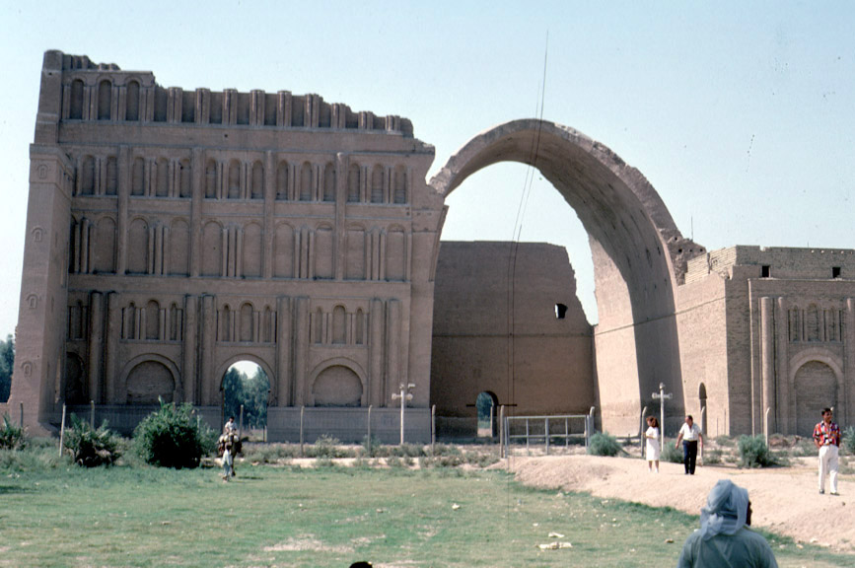
Figure 1: Catenary Arch at Ctesiphon, Iran

Contents
Overview 1
References 3
Introduction 3
Background 4
Additional Loadings 4
Uneven Loadings 5
Examples 5
Casa Milá (Gaudí) 5
Sagrada Familia 8
Development 9
Chain Spacing 13
Cross Sectional Considerations 18
Deployment Example 21
Physical Considerations 23
Lateral Forces 23
Minimum Angles and Ratios 25
Possible work-around: the Catenary Suspension Bridge 26
Physical Chain Configuration 27
Summary 28
Steel Beam Catenary 29
Conclusions 32
Meta-Design Requirements 32
Validation 32

References
- Auroville Earth Institute: web page on Stability Notions: http://www.earth-auroville.com/stability_notions_en.php
- "Gaudí" by Gijs van Hensbergen (Harper Collins, 2002)
- Mathematical Thought – page at University of Arkansas: http://math2033.uark.edu/wiki/index.php/Sagrada_Familia_and_the_Catenary_Arch
- Weisstein, Eric W. "Catenary." From MathWorld--A Wolfram Web Resource. http://mathworld.wolfram.com/Catenary.html
- “Techniques in Engineering Redevelopment”, M Bennett, Hypercube site paper at http://www.hypercube.co.uk/docs/techniques-in-engineering-redevelopment_v3.doc

Introduction
The aim of this example is to explore how arches of varying configuration can be self-designed using the method of hanging a chain to effect a catenary arch and then loading it as required to simulate the detailed requirements of a specific arch. This is based on the work done by Gaudi at the Casa Mila.
This diagram from Reference 1 shows the basic principle of the catenary arch and its derivation from a hanging chain:
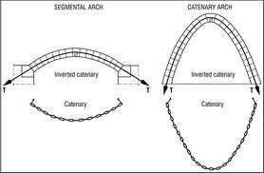
Figure 2: Catenary Arch and Chain
The form of the free-standing catenary ensures that the forces remain within the boundaries of the arch components, so that there are no lateral forces on the structure.

Background
The free-standing catenary is well understood. The precise shape of an arch in which the lateral forces remain contained within the arch structure may be determined by hanging a chain with even weighting, freezing or capturing its shape, and then inverting this to get the shape of the arch. It should be noted that the weight of the chain need not be the same as that of the proposed arch, since both the chain weights and the finished arch weights are in proportion within the chain and within the finished structure.
Further work was done by Gaudí [ref 2] to determine different catenary profiles using weights to simulate the loading of the finished arch, these weights being applied in inverted scale models of the finished arches.
The “epigenetic” approach which this paper is intended to illustrate differs from Gaudí. Instead of using and observing scale models of the inverted arch profiles, the aim here is to determine the profiles of arch sections across a range of un-measured physical spaces, to derive the arch profiles in full size, using the full-size chain model as a physical guide to the construction of the completed arch. That is, the chain is a model in terms of its weightings but not in terms of its physical length or shape.
Note that following construction, the original chain may be attached to the arch as a self-documentation of the “design” of the arch. This provides some means of validation after the effect as well as a lasting record of the design.

Additional Loadings
The unloaded catenary arch needs to support only its own weight. For shapes other than this, the method employed needs to add models of the weightings of the load which the arches is intended to support. Again these are a scale models in terms of weights and loadings, applied to a full sized representation of the completed arch.
This is a full sized implementation of the approach used by Gaudí in his scale models. All weights must be proportionate to one another. They must also be proportionate to the weights of the original chain (which effectively represents the weights of the voussoirs alone). Alternatively, the weight of the chain components must be orders of magnitude less than the simulation weights, and all voussoirs then reapplied as additional weights in proportion to the weight “scale” employed to simulate the loadings (see later section for more details on determining the chain arrangements). This latter approach is closer to the details of Gaudí’s application, which used string rather than chain for the catenary shapes themselves and simulated all loadings in terms of weights appended to these.
In the former approach, where the chain links’ weight is considered to represent the intended weight of the voussoirs, the additional weights added to represent other loadings on the construction must be in proportion to the chain weights. That is, there is a scale relationship between the weight of a length of chain and the weight of a corresponding length of arch voussoirs, and the same scale must be applied in the relationship between the weight of any material in the spandrels of the arch and the weights used to simulate these; the weight of the thing which is to be supported (roadway, railway etc.; though if this is even along its length this may be considered to have no effect on the shape – we should test this assumption); and the intended loadings to be applied to that roadway or railway. If buildings are to be supported these should be simulated by weights in the appropriate places also.

Uneven Loadings
In addition, in simulating the loadings on a completed road, railway or other thing which is to be supported, one should aim also to represent the most extreme of differences between these. A train parked evenly along a railway atop such a construction will have minimal effect on the shape of the corresponding chain, whereas a train resting at one end may alter the shape enough to require some change to the arch shape in order to ensure that all compressive forces remain within the physical material of the arch. Simulation of extremes of difference in loading may therefore be a necessary step in ensuring tolerances and outer dimensions of the material.

Examples

Casa Milá (Gaudí)
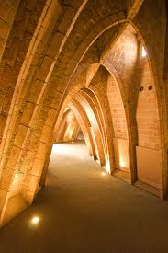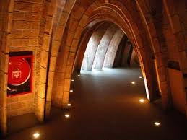
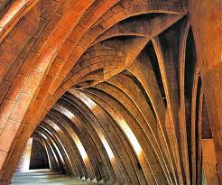
Figure 3: Catenary roof arches at Casa Mila
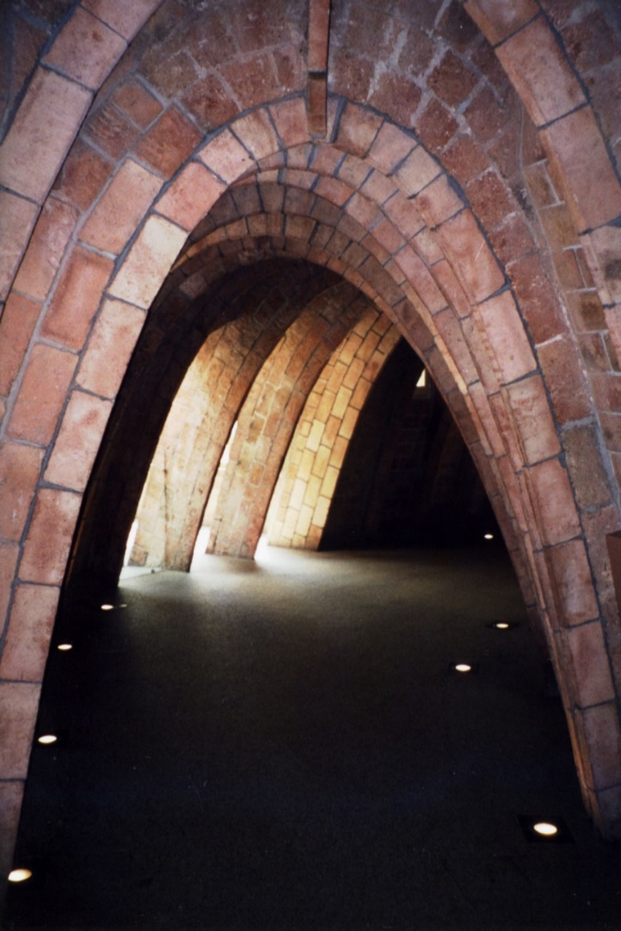
Figure 4: Catenary brick arch at Casa Mila
The loft section of the Casa Mila apartments (also known as La Pedrera) in Barcelona are built using brickwork arranged in a set of catenary arches which support the roof. The roof itself is of uneven loading and so these loadings are simulated in scale models as shown below:
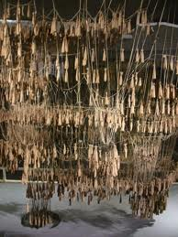
Figure 5: Portion of the catenary model for Casa Mila loft space
Note how the loadings are simulated by weights hanging from the model, while the weight of the strings themselves is negligible in comparison to these and so has no noticeable effect on the model.

Sagrada Familia
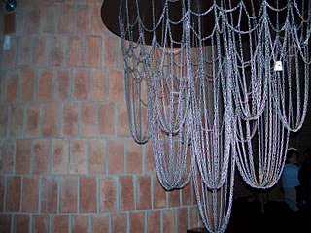

Figure 6: Gaudi catenary model for Sagrada Familia (from Reference 3)
In this second example no additional weightings seem to have been used – this shows the use of free hanging chain in order to arrive at the shapes for a set of towers in the Sagrada Familia cathedral (Reference 3).

Development
We start with the simple illustration of a hanging chain used to derive an unloaded catenary arch (figure 7). Note that in these examples the curves are not accurate portrayals of the catenary shape.
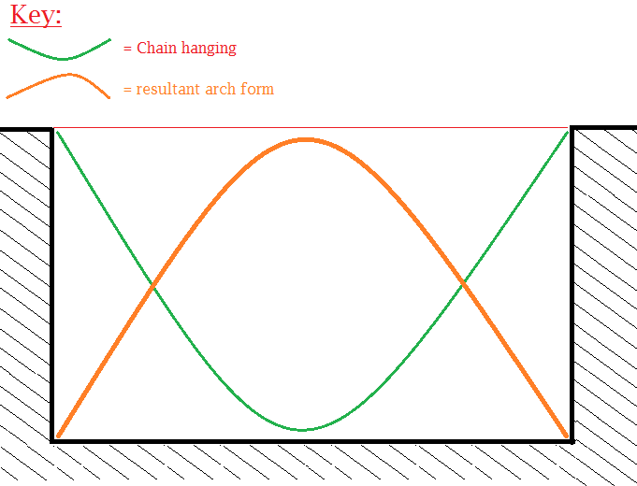
Figure 7: Basic chain and resultant arch form
This is not much use on its own as it is not able to support any uneven loading on the structure.
Next we consider two ways of extending this:
- Support of additional arches to support the loading
- Support of solid material within the adjacent space (the spandrel of the arch)
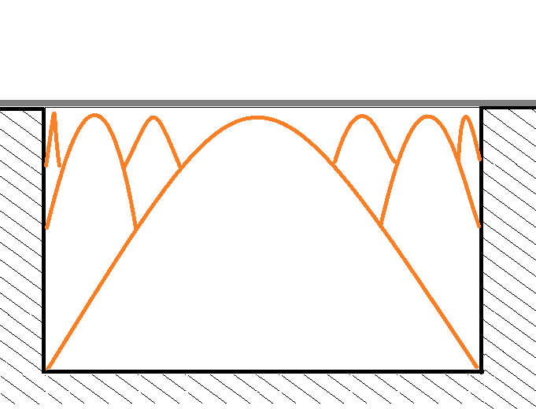
Figure 8: Additional arches
For this configuration, weights would need to be added to the hanging chain to represent the weights of each arch as well as the loading of the apex of each arch.
It should be possible to simulate the entire construction above by hanging chains from chains to reflect the arches above. Further weights would be added at the apex of each chain, simulating the loading of the bridge / road surface at that point.
This may require an iterative process to complete the optimum design, which is not developed further here.

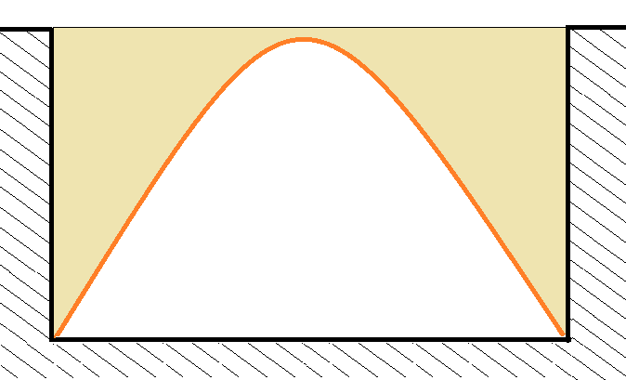
Figure 9: Solid arch structure
Figure 9 shows a solid bridge arch structure. This may be one of a set of narrow arch sections or it may be a completely solid structure.
In order to develop the correct shape / profile for this, the chain needs to be loaded evenly with weights proportional to the weight of the masonry to be added (figure 10). Ideally this would achieved by a series of chains of the same or similar weight to the main one used in the arch shape. The precise distance between the adjacent chains would need to be determined so as to be proportionate to the weight of the material in use – i.e. if the voussoir material and the additional material can be assumed to be of the same density, then the chains need to reflect an even distribution of weight proportional to that.
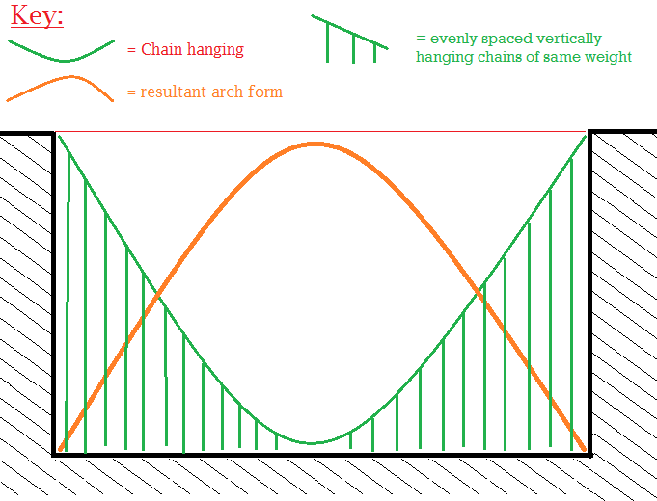
Figure 10: Use of additional chain material to reflect the loading on the catenary

Chain Spacing
How far apart should the chains be in the above? Consider first an arch which is to be made from identical, solid blocks. First, consider an arch consisting of the voussoirs (the blocks which make up the arch) alone (Figure 12).
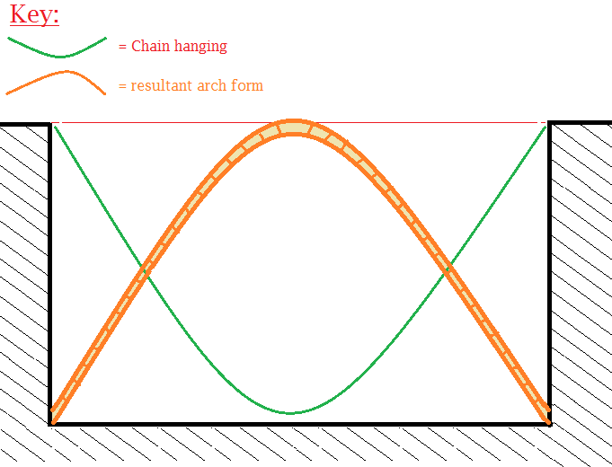
Figure 12: Catenary chain for arch voussoirs only.
Then assume that the rest of the solid arch component is to be made from blocks identical in weight, width and depth. Let’s put these vertically for now (figure 13).
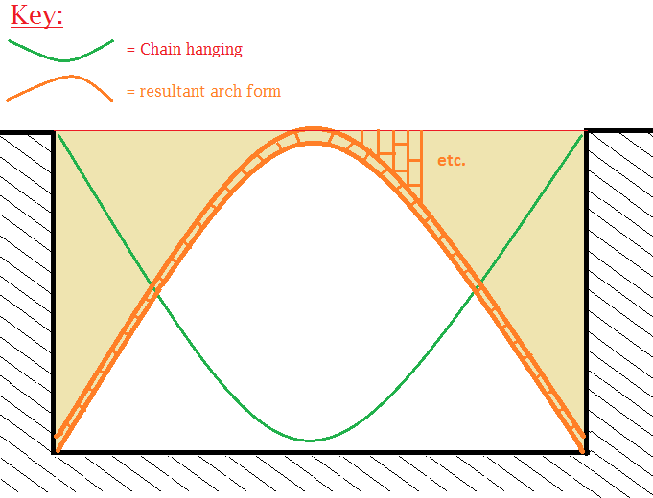
Figure 13: Arch made of vertical blocks (sample shown)
Then, assuming that the wall is of uniform thickness, and the blocks both in the voussoirs and the main wall are of the same width, then a set of identical chains hung one per course of these blocks will be exactly proportional to the weight of the chain representing the voussoirs. Since the main chain already represents the weight of the voussoirs the hanging chains must not duplicate this, so they must end one block’s width from the ground (figure 14).
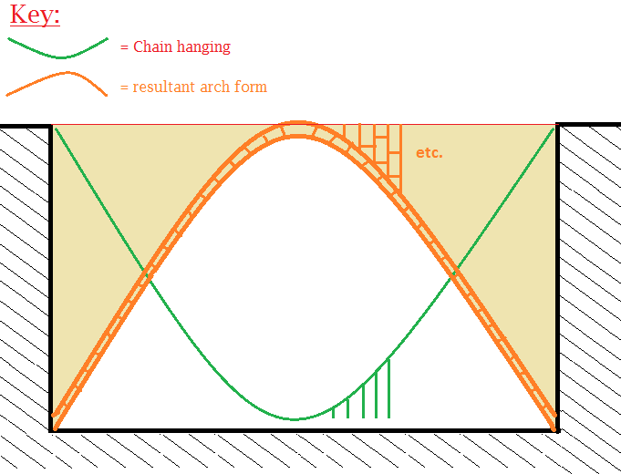
Figure 14: Chains must stop at one stone course distance from the ground (or representation of the top of the structure)
Clearly the same weight will represent the same amount of material if the stones are laid horizontally (figure 15).
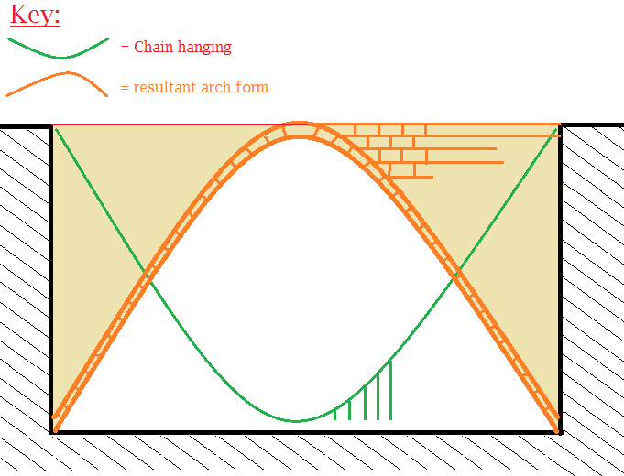
Figure 15: stone courses turned horizontal; weights unchanged
By the same token, if there is no stone coursing at all, but the arch section is made of solid concrete, then the same chain weights still apply (figure 16).
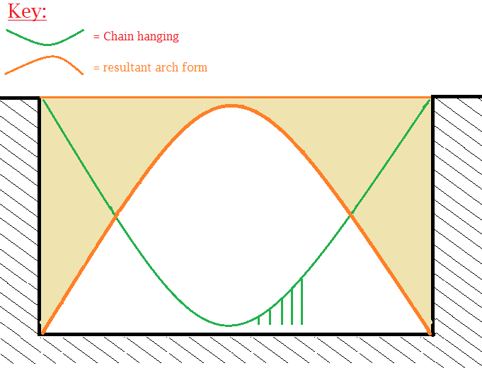
Figure 16: Chains requirement when no stone coursing is present, remains unchanged.
The rule then is:
- “For a constant thickness/depth and density of arch wall the spacing between chains must be the same as the distance they stop above the ‘ground’ i.e. the image of the top of the structure”
With or without stone construction, the additional chains which represent the main structure weight may be as close together or as far apart as you like, provided that they end the same distance above the ground as they are far apart. Closer chains means a smoother curve; further apart chains will lead to a less smooth curve, but uses less chain. This rule remains the same even if stone coursing and voussoirs are used. Also if voussoirs are used but some other material is used in the main arch infill, then if their density is the same, the same rule applies.
For all other weights, the weight to be added should be determined by applying the ratio of chain length in the above structure to the weight of the building material corresponding to that length of chain, multiplied by the thickness of the wall section and the distance between the chains (giving the volume) multiplied by the density of the material.

Cross Sectional Considerations
Depending on the internal structure of the bridge, there may be additional weighting. For example, suppose that instead of being a solid bridge / tunnel section, a bridge is made up of several discrete sections. This is shown in cross section in Figure 17.
Different cross sections may be appropriate, and would be determined by an engineer. The example which follows is for illustration and assumes that some cross section design has been determined.
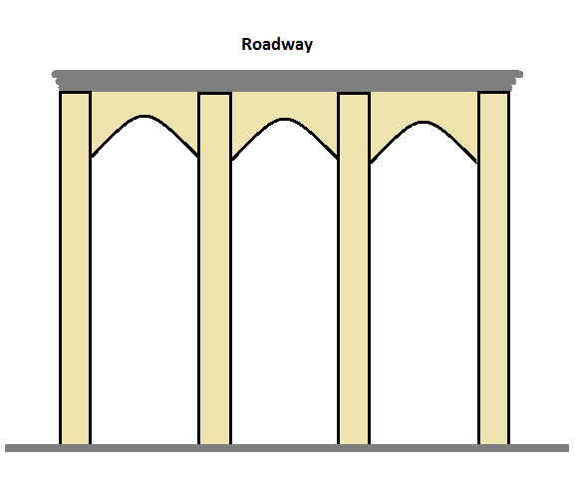
Figure 17: Cross Section example
In this example, a suitable design has been arrived at by a civil engineer, in which four discrete arch sections are used to hold up the bridge, with additional lateral support arrangements at regular intervals. The thicknesses of the arch sections, the design of the lateral support members and frequency with which they appear along the length of the bridge are all determined by the civil engineer. These provide the specified level of support for the roadway or other loading, and are independent of the self-design of the arch catenary shape. The lateral support is shown here as smaller catenary arches but may as easily be round arch brickwork as seen for example in the New York subway.
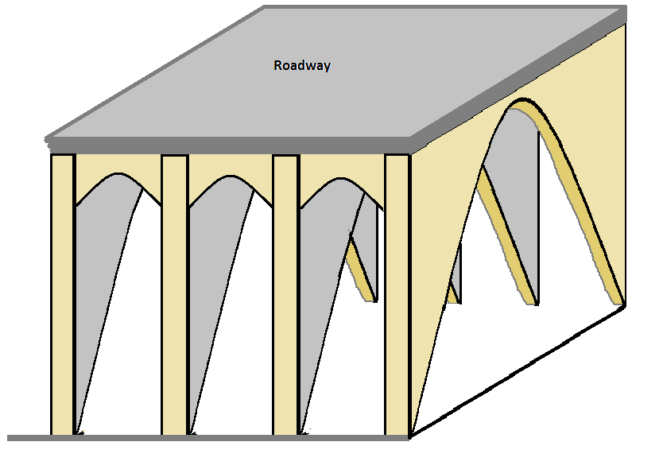
Figure 18: Hypothetical design with multiple arch sections and lateral support
This design is hypothetical since the precise design of these aspects of the item would be determined by a competent civil engineer, taking into account the forces of the roadway or other loads.
Note that the lateral support may itself be continuous or may be in the form of discrete cross members which are a specific distance apart. In the latter case, the uneven loadings of these cross members needs to be taken into account in the chain model. The engineer would also determine the distance between these lateral members, as a single repeatable value which is implemented across all sections. To avoid design challenges, the top of all arches would also need to be below the height of the cross member so that if or when the cross section occurs at the apex of the arch there are no unexpected contradictions in the design (this is another example of the sort of consideration to be thought of when arriving at a metadesign in any epigenetic implementation).
This is then taken into account in the chain configuration as shown in Figure 19:
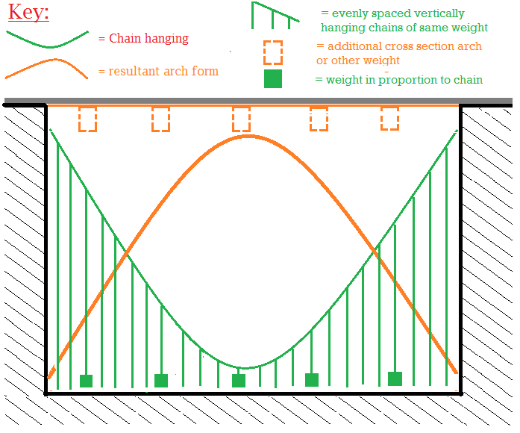
Figure 19: Weights for additional cross members

Deployment Example
Finally, we can consider how these techniques would be applied “in the wild”, to determine a set of arches for a scenario in which a number of items need to be crossed by some new roadway. To complicate matters further, we will consider that the required roadway is not at a level – so that the approach needs to be further modified to determine the precise shape of the catenary arches for a sloping roadway.
Figure 20 shows the initial requirement.
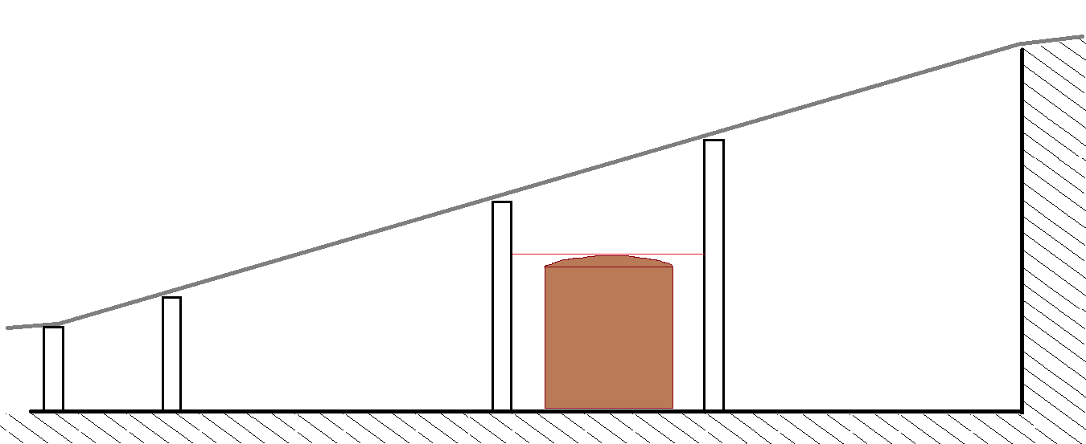
Figure 20: Cross section of bridge requirement.
Note that one of the areas to be spanned is a railway line; the clearance required is represented by a train (to be truly epigenetic, a train would be parked here in reality). Realistically, other roadways would also have height requirements which might also need to be marked out.

The resultant bridge needs to look something like Figure 21, but first it needs to calculate itself using the chains method.
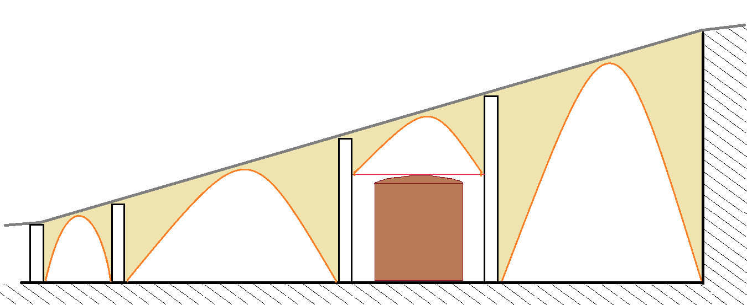

Figure 21: Lateral view of the required bridge.
Since the bridge sections are on a slope, an additional construction is needed in order to ensure that the shape of the chain is an accurate reflection of the required arch. This is literally a reflection – so we need to plot out the position of the ground or the arch footings in reverse. Figure 22 shows the construction requirement.

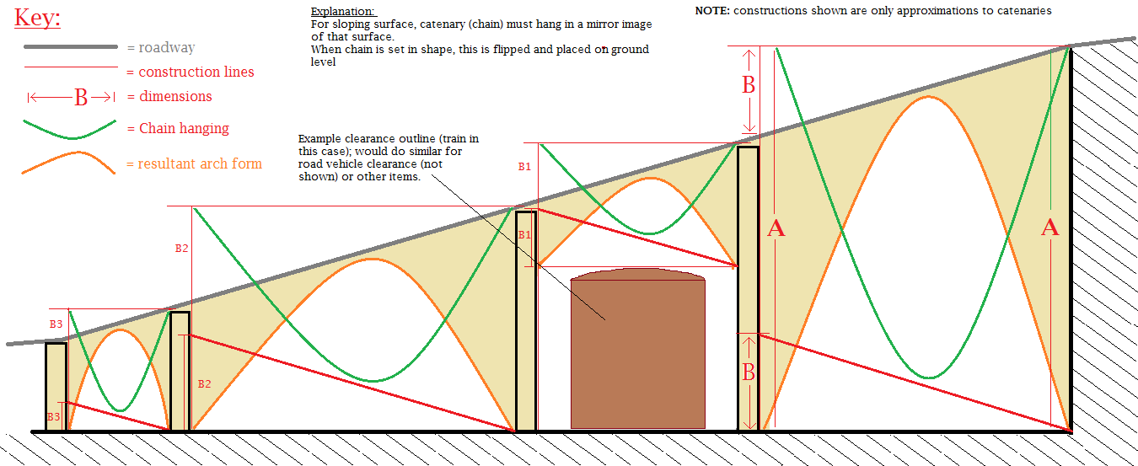

Figure 22: construction requirements for catenary design of flyover section.

In order to complete the chain shape, one must extend the lower side of the span so that it is level with the upper side (using for example a piece of wood). Then the roadway or whatever it is that is to be supported, has to be simulated in reflection by measuring the length of this extension (shown as B on the far right span, and then B1, B2 B3 on the others). Attach a straight item between the point a distance B from the ground or footing on the left, to the bottom of the higher side of the span on the right. This represents the roadway, in reflection. The chain must reach down to within the distance that the completed arch is to be from the roadway.

In Figure 22 the additional downward chains and any weights for cross members are not shown but these would be present.

Physical Considerations
There are a number of physical considerations not covered in the outline above, which would require additional detail both in the conventional engineering design aspects and in the meta-design. These include:
- Lateral forces from the feet of the arches
- Allowable minimum angles / height to width ratios
- Physical construction of the arch from the catenary chain

Lateral Forces
The nature of the catenary is such that all catenary arches will meet the ground or footing at some angle from the vertical. This means that there will always be some lateral forces to be handled (figure 23).
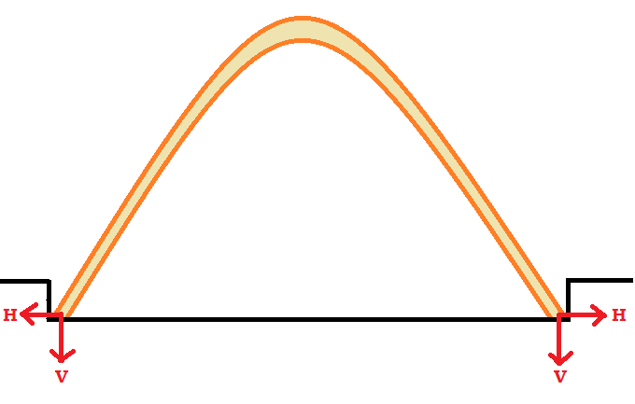
Figure 23: Vertical and Horizontal Forces on Catenary
To this end the foot of the arch must always be buttressed, for example within the ground or by a well-engineered or over-engineered buttress.
Alternatively, an opposing similar force from an adjacent arch must be present, with the engineering of the buttress being such as to absorb any differences between the lateral forces of the two arches.
Given that the precise dimensions (and therefore forces) of the arches are unknown, the engineering of any buttress much be such as to be able to absorb the largest anticipated differences between adjacent arches.
Note that in the example given in figure 16, the section shown as a railway line will present forces to the side of the buttress, which need to be dealt with (see figure 24). Otherwise the vertical buttress may collapse during construction and will present un-allowed for lateral forces to the adjacent arches.
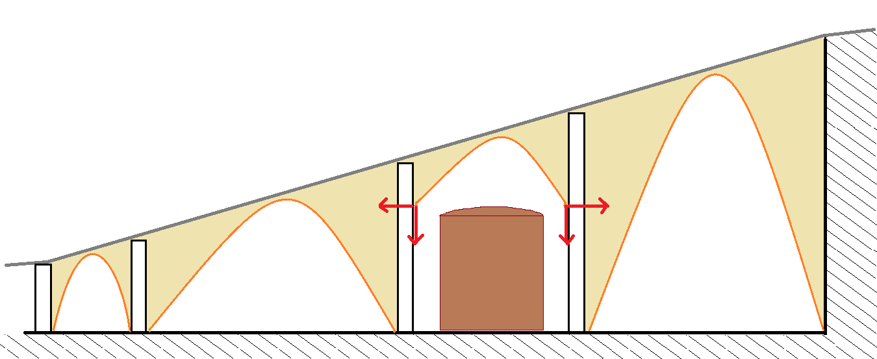
Figure 24: Lateral forces within buttresses
Realistically therefore, the meta-design should require that adjacent elements be positioned at a similar position vertically, or that the buttress members be reinforced such as to be able withstand any such differences (figure 25).
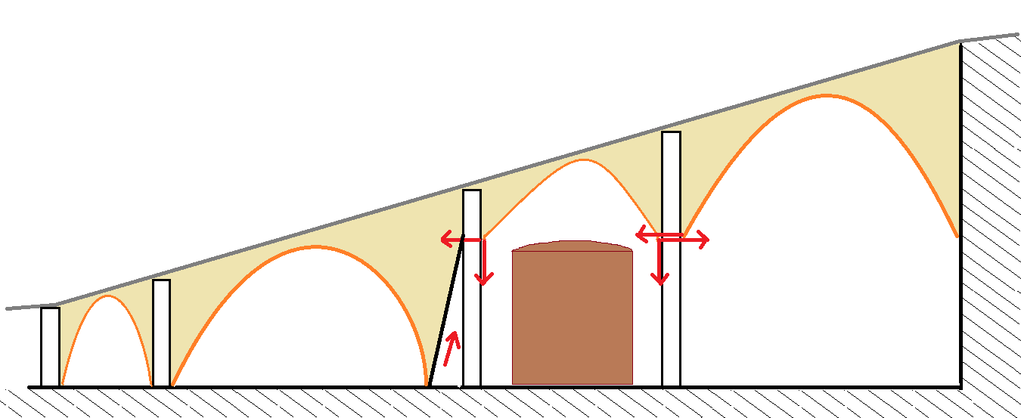
Forces balance
Forces balance
Additional buttress
Figure 25: Example solutions to lateral forces not at ground level.
Again these are illustrative only, and are intended to indicate both an epigenetic solution (specifying that adjacent arches be placed within some define vertical distance so that any differences between forces are within the capabilities of the upright buttress member), and a conventional design solution (the additional downhill buttress, used because it is not possible to place a catenary arch with its foot at the required height on the downhill side).
In fact the additional buttress shown is made of the same stuff as the rest of the bridge section, so it should be possible to come up with a way of deriving the shape epigenetically. To do this, we take a tip from Gaudi and use the system of chains to determine multiple arch shapes taken as a single unit, rather than treating them individually as we have to now. Figure 26 shows what the result of this might look like. Here we have taken the entire bridging system, created the inverted roadway image and the image of the required clearance(s), and then calculated a system of chains spanning the whole required space.
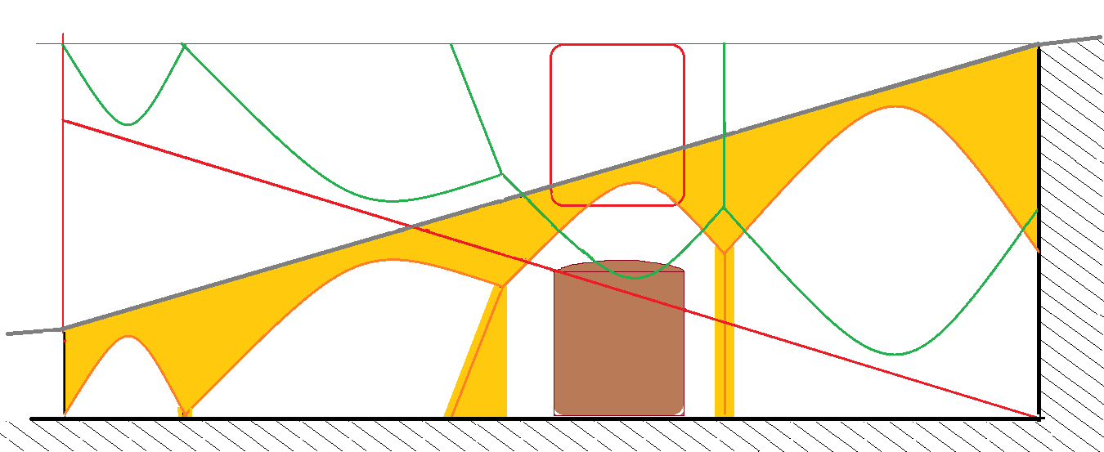
Figure 26: Multiple arch sections as a single catenary calculation.

Minimum Angles and Ratios
For a given type of material and meta-design, there is bound to be a minimum angle at which the catenary arch may be placed (figure 27).
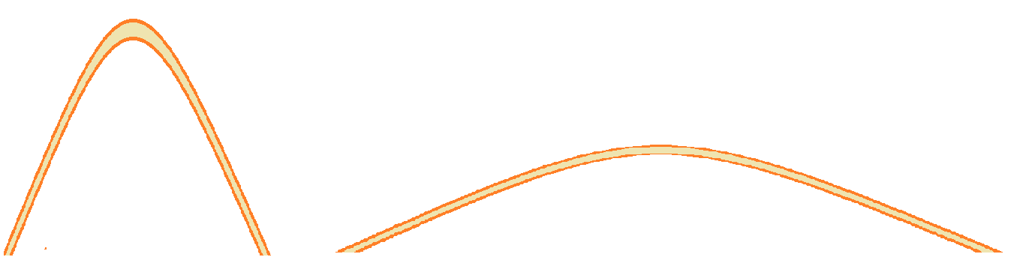
Figure 27: steep and shallow catenary arch profiles
As we saw in Figure 1 (the “Segmental Arch” on the left hand side of the diagram), the angle of the catenary can be quite shallow if one assumes that the feet are firmly planted in some buttress which is able to withstand considerable lateral force. Even then, there are limitations for each material for how much shear or variation in force it can take before it buckles (at the extreme case, the arch is no more than a horizontal bar).
Therefore the engineer needs to determine a maximum angle from the vertical for each arch. This should be provided to site as a “former”, perhaps in the form of a wooden cut-out. If a space is to be crossed and a chain cannot be hung across that space without either touching the ground or exceeding the angle shown in the former, then that space cannot be spanned in a single span using the chosen materials and cross section design (figure 28).
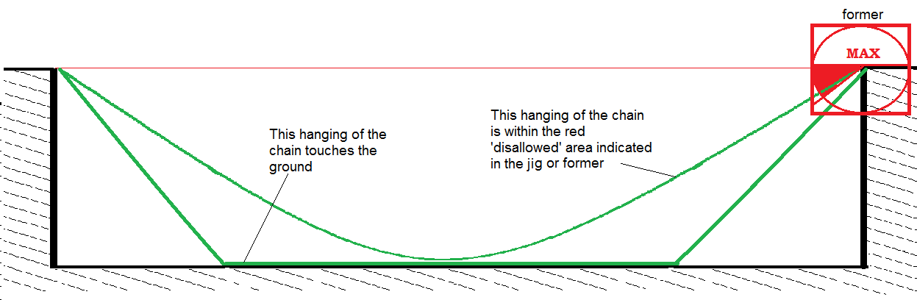
Figure 28: Chain which cannot be hung within allowed tolerances
These tolerances are themselves determined by the civil engineer. Provision of the jig or former is part of the epigenetic approach to ensuring that the design tolerances are not exceeded in the actual expression of the meta-design.

Possible work-around: the Catenary Suspension Bridge
There is one possible work-around to the challenge presented above. This is shown in Figure 29 which can be clearly recognized as a suspension bridge. Additional techniques need to be made available within the meta-design, to allow for suspension components.
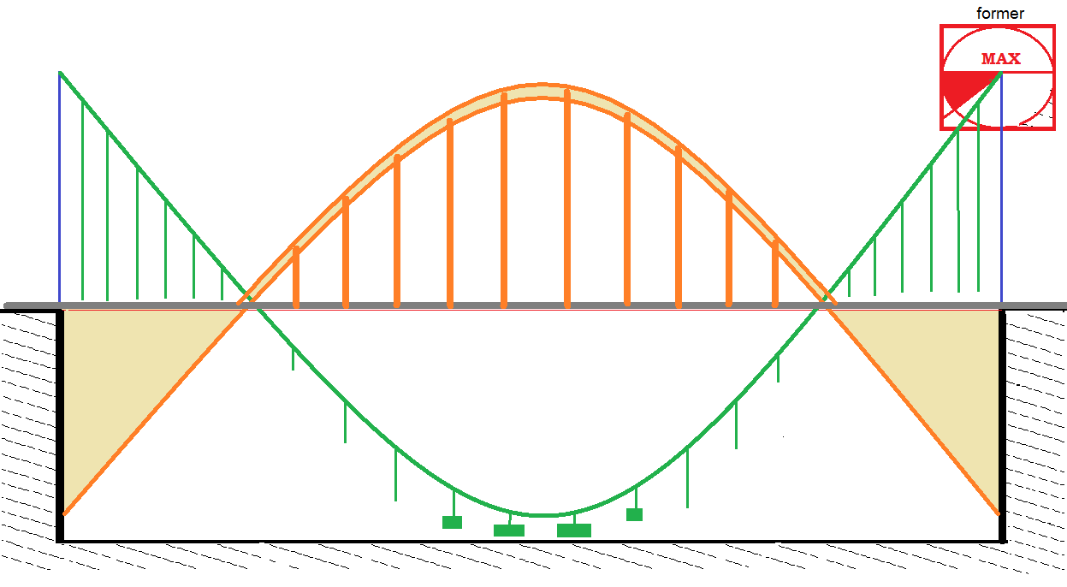
Figure 29: Catenary Suspension Bridge (also showing chain weighting)

Physical Chain Configuration
So far we have simply described the hanging of a chain, and left the inversion of this as an exercise for the user. Clearly the method and materials to be used for this have to be determined as part of the overall meta-design for this construction method.
One obvious method, perhaps the default, is to build shuttering above and around the hanging chain and then invert this in order to pour concrete (if this is the chosen construction method; a similar wooden former may be used for bricks or stone, with reinforcements as needed).
A more elegant method is to find some means of “freezing” the chain. This method must not cause differences in weight along the chain while it is happening. For example, the chain may be coated or sprayed with a cement mix, which must not run down the chain before it sets. Once set, the chain may be inverted and used as a guide for brick coursing or for the creation of wooden shuttering in situ.
Another alternative may be use of sacking, with a cement solution applied to it in an even layer. Again there is a risk of slippage, which would cause the weight to become unevenly distributed.
Another alternative, again using sacking, would be to use a boiled maize meal solution. This is less likely to slip down the sacking “chain” due to its properties. Unlike cement, the maize meal solution would not work with metal chain.
It may also be possible to develop a bespoke chain construction. This might for example have a uniform, flat cross section so that when it is set it is able to become a former or a guide for brick or stone directly. Something like Figure 30.
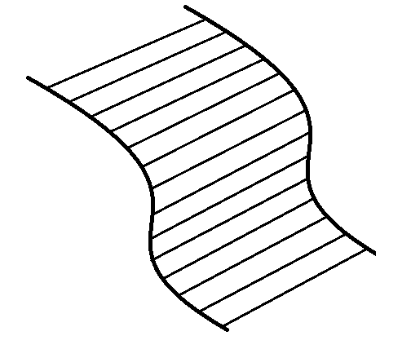
Figure 30: Flexible, broad flat chain enables the creation of a flat former to work against
This would have to be designed in such a way that an amount of cement is trapped in each joint and does not migrate down the length of the chain. Something like Figure 31 which shows a chain joint in which one pair of side members is attached to a paddle which sits within a chamber that has an opening into which some setting compound such as cement, adhesive etc. is poured – ensuring that this does not migrate down the length of the chain but is retained in even proportions in each joint.

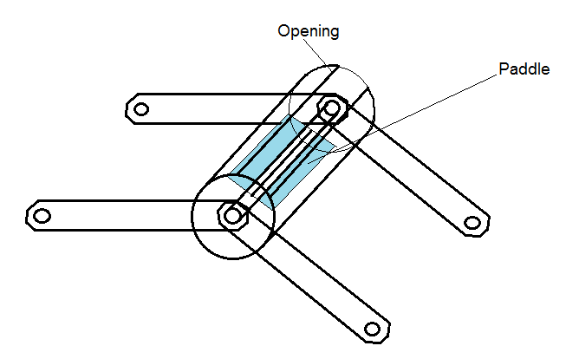
Figure 31: outline of suggested chain joint for settable flat linked chain
This is almost certainly overkill. An ideal arrangement would be if it were possible to combine a kind of chain mail of a given weight and thickness, with some material (glue or epoxy resin or maize meal) which was able to “freeze” the chain in the position in which it has been hung. This would not be used as a load bearing former but as a guide only.

Summary
In terms of the chain element of the catenary, there is scope for research on what are the most effective methods for creating something which can hang freely and can be set into shape without distortion to the weight distribution along the length of the catenary. It may prove that sacking and maize meal is adequate for most purposes. It may be that fine chain mail with maize meal does the job. At the other end of the scale there may be scope to develop something which is more like a pair of cycle chains separated by bars and with some added component to allow even distribution of cement. The latter idea may be capable of carrying sufficient weight for example to add tiles, bricks, or even a course of light but compressible blocks in some material onto which heavier additional masonry may be added.

Steel Beam Catenary
Another possible way of using this principle would be to create a steel beam section directly from a free-hanging catenary construction as shown in Figure 32:
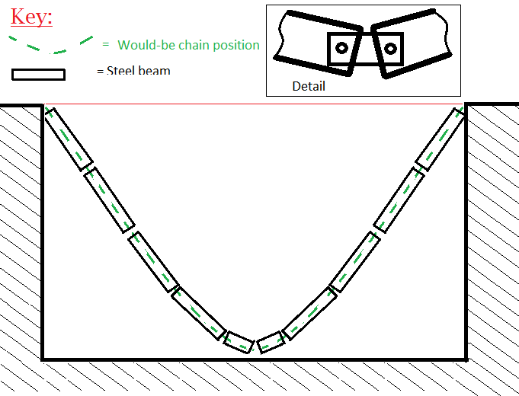
Figure 32: Beams suspended in a catenary arc
In this arrangement, the beams are suspended via a single bolt for the free hanging chain position. Then holes may be drilled and additional bolts inserted to create a stable frame which can be loaded or built upon (figure 33).
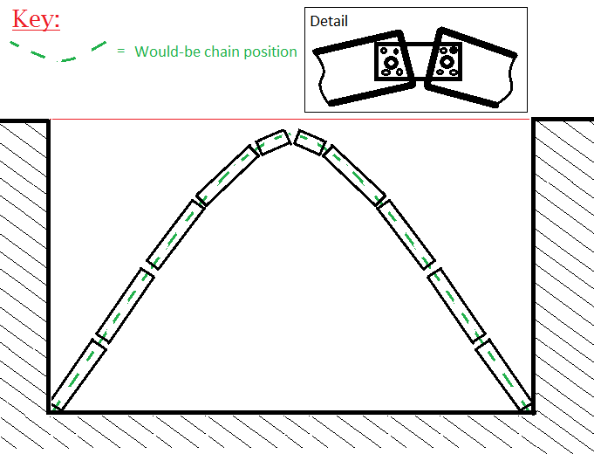
Figure 32: the catenary beam arrangement becomes the load bearing beam.
Once again this may be loaded as required, for example as in Figure 33.
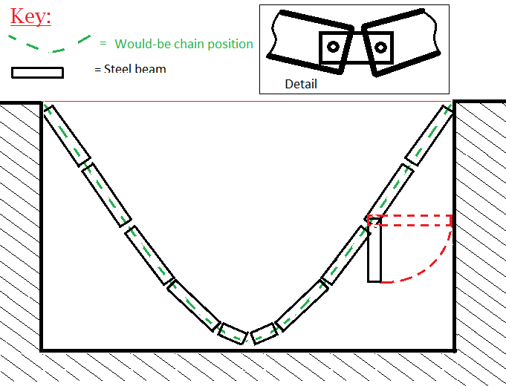
Figure 33: Additional loading for cross beams (longer cross beams would be at double or triple density to avoid dragging, not shown)
This can then be used to provide support for, for example, suspension of material within building frames or other means of attachment.

Conclusions
Following this method, a set of different arch profiles may be arrived at. The other dimensions of the bridge, including thickness of the arch sections, frequency and nature of any cross members and so on, is designed by a civil engineer and remains the same throughout the length of this and any other spans on the required roadway – so that aspect only needs to be designed once. Tolerances needs to be built in, both for possible errors / variance on site, and to over-engineer the solution.
As such, this method fits into the philosophy described as “epigenetic engineering”, since it provides for the build of an engineering artifact without the mediation of blueprints. The method provides epigenetic or non-blueprinted design for one dimension (the arch profile) on the basis that other dimensions are conventionally engineered. The continuous lengthwise design may be applied to any number of bridges which are to support the same load. For rail, additional tracks may repeat the same designs.

Meta-Design Requirements
The method given above constitutes a meta-design within the paradigm described as “Epigenetic” in [ref 5]. In common with many such proposals, the system uses a combination of approaches not all of them epigenetic in nature. These include:
- Conventional design and engineering: a civil engineer determines the cross section profile and materials;
- Economic balance: the materials and techniques chosen by the engineer should strike the optimum balance between cost, availability etc. in selecting materials and building techniques, including the possible use of alternative, local materials (baked brick, use of rubble in the arch spandrels etc.);
- Modularity: in the example where a cross-sectional arch is inserted at regular intervals, this is a modular design reapplied along the length of the construction. Note the appearance of an irregular “stub” in figure 13, in which the regularly repeating design is implemented from the right hand end of the arch as viewed;
- Over-engineering: in addition to the over-engineering apparent in the irregular short stub noted above, all components are over-engineered to ensure that they remain within tolerance given the unknown variances in the arch implementation. This is particularly important in over-engineering for the maximum possible variance in lateral loadings between one arch section and the next. This effectively trades the cost of the additional materials, for the cost of designing each section;
- Epigenetic method: the lengthwise sections of all arches in this example are never measured and never set out in a blueprint. The completed design is expressed once only, in the bridge itself. All determinations are made with reference to the epigenetic “seed” (the chain) and the environment in which it finds itself (embryology).

Validation
In addition to the meta-design aspects, some implementations of this method would explicitly cover for validation of the completed “design” or configuration of the arch section. To do this, the builders would simply attach the chain to the side of the completed item. This would not work in cases where the chain itself is included within the bridge material, for example when shuttering is built around and below the chain.

Voussiors are the stone or brick components which (along with the keystone) make up the curved structure of an arch.

