FIBO-LE SME Review
31 October 2012

Executive Summary
This week we reviewed the proposed revisions to the business entities taxonomy. This included a proposal to define "Legal Entity" as a context-specific term, reflecting the fact that what is or is not regarded as a "Legal Entity" is defined in some context, namely some jurisdiction. This simplifies the diagram, in that the kind of independent entity which is the form that the Legal Entity may take, is any "Formal Organization", that is any organization that has some contractual basis among its principals. Meanwhile, Body Corporate (also known as artificial legal person) is made a sub-type of Formal Organization on the basis that only an organization, and only one which is formal, may be created or constituted as a legal person. This greatly simplifies the hierarchy in that most of the things we are interested in are now kinds of organization, while human beings as individuals are in a separate part of the hierarchy.

These changes were all agreed.

We then went on to look at the kinds of business entity which were of relevance in funds and other collective investment vehicles. There are several forms of fund and CIV so we are not expecting to come up with a "one size fits all" picture of fund related entity, but rather we want to make sure that for each of the main kinds of funds which exist in the jurisdictions we know about, the kinds of business entity that need to be described are covered in this first version of the FIBO Business Entities model. These include fund special purpose vehicles, and trusts.

During the session we established a lot of new facts about how trusts are used in at least some fund related contexts. We also talked about special purpose vehicles more broadly, and it is clear there is a lot of commonality between fund SPVs and MBS/ABS SPVs. We will therefore expand our exploration of business entities to include these. This will be the first topic for next week's session.

Participants took an action to investigate the various forms of "Fund" that are known to their firm, and come back next week with details.

References
1. "Special Purpose Vehicles and Securitization", in "The Risks of Financial Institutions", National Bureau of Economic Research, Gary B. Gorton and Nicholas S. Souleles - at http://www.nber.org/chapters/c9619.pdf

CONTENTS

Executive Summary 1
References 1
Agenda 3
Resolutions 3
Taxonomy 3
Discussion Summary 4
Validation of Re-crafting Taxonomy 4
Legal Entity Revised Taxonomy 4
Trusts 4
Three Things called Fund 5
Funds Legal Entities 6
In Session Diagram Notes 8
Diagram Notes and Detailed Discussion 8
Funds Entities Review 8
CIV Simple 10
Trusts Figure 10
Relative Business Entities Taxonomy 12
Trusts Figure 13
Relative Business Entities Taxonomy 14
Trusts Figure 15

Agenda
- Review proposals for Legal Entity as contextual concept
- Trust
- Funds: Three things called Fund
- Fund related business entities

Resolutions
This section shows:
- Resolved: Things that the group has agreed upon in this call
- Proposed: suggested model changes to be reviewed later
- To research: Things to research and revert with model proposals.
- To be determined: Decisions to be made on scope, relevance etc. at a future session

Taxonomy
- Resolved: Legal Entity as a "Relative Thing"
- Body Corporate (artificial legal entity) as a child of Formal Organization
  - Removed the previous parent relationships to Formal Organization from specific sub-types of Body Corporate - they are all Formal Organization by inheritance from Body Corporate

There were no comments or questions on this new taxonomic structure
The intended meanings and definitions of each concept remain unchanged.

Discussion Summary

Validation of Re-crafting Taxonomy

Legal Entity Revised Taxonomy

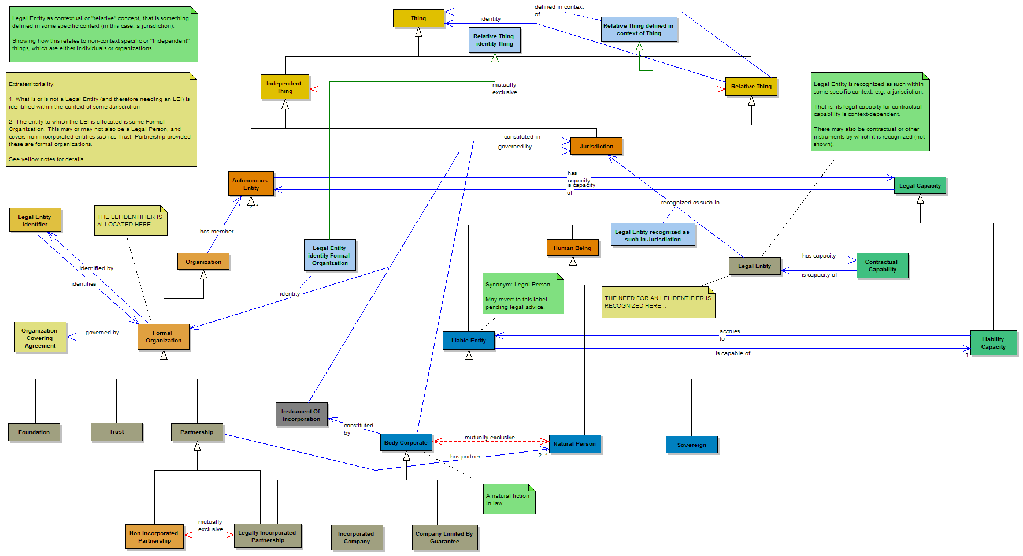

Figure 1: Revised Taxonomy of Legal Entity and Formal Organization

Trusts

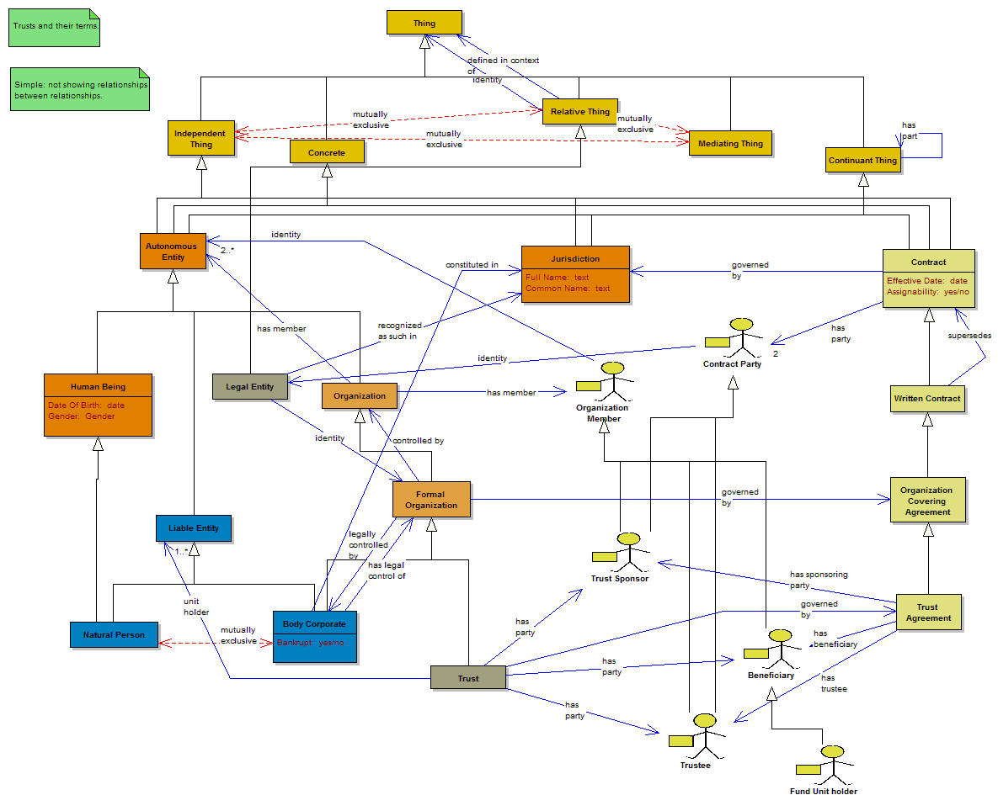
Figure 2: Trusts Diagram

Three Things called Fund
An extract of the existing fund related business entities concepts is shown in Figure 3. This model was based first on the ISO TC68/.SC$ Working Group 11 work (which became the FIBIM model in ISO 20022), and then on a later set of review sessions with European funds domain experts from EFAMA.

The earlier reviews had identified that there are three possible things that people are referring to when talking about a "Fund": the thing with a security identifier (CUSIP or ISIN); the thing that is a pool of assets under management (with related fund management company, portfolios, fund strategy etc.); and the thing which is a formal business entity that is the legal form of the fund.

In some (or all?) fund related structures, some entity exists which has equity, and this equity is sold as fund units (specifically fund equity units; there are other forms of fund unit). Holders of those equity units participate in the fund, that is they hold a portion of the equity in the fund. There are variations around closed versus open ended funds.

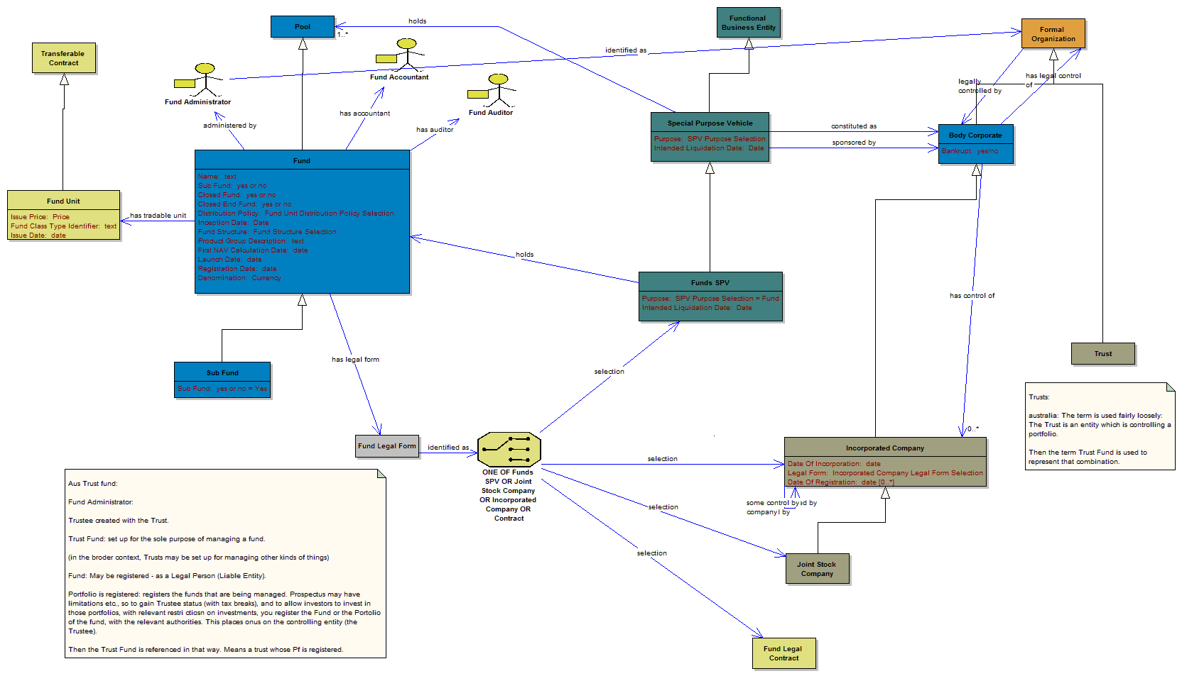

Figure 3: Existing fund basic terms

For the purposes of these business entities reviews for FIBO-BE, we need to identify all of the types of business entity that need to be modeled in FIBO-BE. These will include independent forms of entity (like limited companies), and also entities defined by their function such as special purpose vehicles. Note that when the above model was last looked at in the Funds/CIV SME reviews, the concepts of a functional (i.e. relative) business entity did not exist in the model. We anticipate that the terms captured on those previous reviews will be modified considerably during the current series of reviews, and that is our purpose today.

Funds Legal Entities
This week we focused on the role of trusts as they relate to funds. We started by looking at some jurisdiction-specific scenarios, with Australia as an example.

It seems that this is not simply a matter of funds being either trust based or based on some other legal entity. Rather, at least in the scenarios we looked at this week, a trust has some role with regard to the fund, and the fund itself may be some other entity. There is also a scenario where the beneficiaries are the holders of some interest in the fund. We did not fully tease out the difference between these two presumably different scenarios.

We also looked at special purpose vehicles. As we established last week, the SPV is a kind of "Relative" entity, being defined in terms of its function as an SPV while taking the form of one or another type of formal legal person (Body Corporate).

This is true regardless of whether the SPV is a fund SPV or one used in the issuance of asset backed or mortgage backed securities. There are already three types of SPV defined in the model (the third being used in the issuance of Participation Notes). It turns out there is more commonality between these than was initially thought. We looked at the existing model material where these appear, i.e. the detailed securities model sections for CIV/Funds and for ABS and MBS securities.

Some model changes were agreed, including broadening the range of possible entities that may be the form of an SPV, to include all Formal Organization (that covers Legal Persons plus non legal person forms such as trusts).

We confirmed that there are several distinct scenarios in which trusts and SPVs are or are not in play. More research is needed on these.

Next week we will look into SPVs more generally. Some actions were taken to establish the business facts around SPVs, also known in some places as Special Purpose Entities (SPEs). We established that these are synonymous. We also established that the concept of SPV or SPE applies specifically to the context where the vehicle is created to move some assets off the balance sheets of some other entity (the sponsor), and does not apply in cases where this is not the case, for example a legal entity created specifically to be an investment fund but not moving things off some existing balance sheet. This is where there will be significant differences between funds set up for the investing public, and funds of assets used as collateral in the issuance of securities backed by some pool of debt. These are both now in scope.

There is some valuable detailed information about SPVs / SPEs in Reference 1, "Special Purpose Vehicles and Securitization".

In Session Diagram Notes
This section shows the notes taken on screen while we spoke. We moved from one diagram to another quite a lot, so the notes are shown in order, along with explanation and discussion at each point.

The notes may also be seen on the diagrams in the model file. The diagrams we looked at, and on which we took notes this week, are:

- Relative Business Entities Taxonomy
- Trusts Figure
- Funds Entities Review
- CIV Simple

We also look at, for reference only:

- Funds Entities and Basics
- Mortgage Backed Security Simple
- Synthetic CDO Locator

Diagram Notes and Detailed Discussion

Funds Entities Review
We started the session by reviewing the diagram for basic fund related as it stands (figure 3).

For the purposes of this part of the session, we wanted to establish what are the possible legal forms which a fund may take. According to previous review sessions (e.g. with EFAMA), the legal form which a fund may take include

- a funds special purpose vehicle (SPV);
- a company incorporated by the issuance of shares
- a trust
- some contractual basis (thereby presumably forming some kind of "Formal Organization" in terms of the definition we have for those).

Note that trusts are not shown on the diagram for fund related entities - we need to know about these.

Trusts - Australian Examples

Trusts:

Australia: The term is used fairly loosely: The Trust is an entity which is controlling a portfolio.

Then the term Trust Fund is used to represent that combination.

Discussion:
We started the conversation off by asking what types of fund related entity were known in various jurisdictions known to the participants, and in particular what we could establish about trust funds, or about trusts that relate to funds in any other way.

It appears that in this jurisdiction (and probably others), the term "Trust Fund" describes a fund in which the assets of the fund portfolio are controlled by a trust.

Does this mean that the trust acts in the role of "Fund Administrator"? In the existing CIV model the fund administrator is a separate party which has a role in relation to the fund, and is distinct from the legal form which is the fund itself.

Australian Trust Fund

Aus Trust fund:

Fund Administrator:

Trustee created with the Trust.

Trust Fund: set up for the sole purpose of managing a fund.

(in the broader context, Trusts may be set up for managing other kinds of things)

Fund: May be registered - as a Legal Person (Liable Entity).

Portfolio is registered: registers the funds that are being managed. Prospectus may have limitations etc., so to gain Trustee status (with tax breaks), and to allow investors to invest in those portfolios, with relevant restrictions on investments, you register the Fund or the Portfolio of the fund, with the relevant authorities. This places onus on the controlling entity (the Trustee).

Then the Trust Fund is referenced in that way. Means a trust whose Pf is registered.

Discussion:
Here we described in more detail what are the precise arrangements by which the roles that are defined for Trusts in general, are applied to the management of funds in a trust fund.

To recap, the trusts model has specific parties defined for any kind of trust (whether or not this is a fund related trust entity). These are:

- Trustee
- Beneficiary
- Sponsor

The roles of these parties in relation to a fund are described above. In this scenario, the trust fund has a trust which is set up specifically for the purposes of managing some fund.

Note therefore that the trust is not the legal form of the fund, but it is the legal form of the party which has the role of Fund Administrator. This role was previously identified in the EFAMA reviews, and defined as a kind of "Party" but we did not try to articulate what legal forms that party might take.

Registration here is the registration of the trust fund with the relevant authorities tasked with oversight of funds, and is not related to registration of an artificial legal person ("Body Corporate").

Part of the responsibilities described here is to ensure the fund is managed in accordance with the defined fund strategy and related concepts - these are defined in the CIV model - we took a quick look at these on the diagram "CIV Simple" which reflects most of what is in the CIV / Funds section of the model.

CIV Simple

Fund Strategy, Prospectus etc. in CIV Simple

In a trust fund (Aus), the strategy related concepts are enshrined in the Trust Deeds.

There are variations e.g. in tax breaks from one jurisdictions.

Discussion:
More on the fund strategy and related concepts. In the case of a trust fund, the Trust Deeds (the legal contract which gives a trust its formal structure - see Trusts model), includes material about the fund strategy and other compliance related concepts.

Model action: we can specialize the contract which is a "Trust Agreement" (AKA trust deed), to include the provision of these kinds of contractual terms, for the kind of trust which is a trust fund.

In general, we should be able to extend the most general Trust model, to describe specializations of Trust concepts as they relate to funds. There may be several such specializations for different kinds of fund structure where trusts are involved.

Trusts Figure

Trusts Model for Funds

Specializations on this model for Funds:

Beneficiary = Unit Holders.

Discussion:
From the above conversation, it is clear that the party which is a "Beneficiary" in trusts generally, can be sub-typed to a kind of beneficiary which is the unit holder in at least one kind of fund. We added this to the model as a sub-class of Beneficiary.

Note on Trustee

The person legally responsible for the trust and acts in a fiduciary capacity for the beneficiaries and is appointed by the Sponsor.

In funds: no difference. Except that the Fund in those circumstances is a SPV. The Trustee undertakes to comply with his deed. Because of that undertaking, it is registered as a security with trustee status.

Discussion:
Having defined the specialization of Beneficiary, we looked at whether there is an equivalent specialization for the party which is a Trustee. The definition given above is applicable to any kind of trust.

Question: is this any different for trusts as they relate to funds?

Answer: the responsibilities of the Trustee are no different. However, the fund itself (the legal form) takes the form of a special purpose vehicle, and it is to this that the Trustee has the responsibilities described. The Trustee is still responsible for the duties defined in the Deed (the formal contract which gives the Trust its contractual standing) however this deed itself will have more detailed requirements and responsibilities as applicable to its function as a fund. Therefore this deed would need to be specialized (and as noted elsewhere, there is potential to articulate more of the kinds of contractual terms that may exist, as classes of "Contract Terms Set").

Then, the kind of instrument which is a "Unit" in the fund (analogous to, or possibly a type of, Security), may be registered as being a security with trustee status - see previous note on registration.

Jurisdictional Variations

Possible jurisdictional variations:

Discussion:
Having looked at the Australian example of a Trust Fund, we wanted to establish what jurisdictional variations there are. We didn't make detailed notes on this, but the US participants on the call confirmed that so far, this scenario sounds applicable to funds in that jurisdiction also.

There is more work to do in teasing out the possible variations both in types of fund, and in the way these may vary from one jurisdiction to another. So far, we seem to have captured the generalities in a reasonable jurisdiction-independent way.

Trust v SPV

What about the SPV here?

The Trustee is managing a Pf of assets - so their purpose is exclusively for that.

This aligns with the concept of a SPV, though not explicitly referred to as that.

Discussion:
Previously, we had assumed that funds either related to / had some involvement of a Trust (Trust Fund) or did not. From what we have heard so far, it's not that simple, since there is at least one scenario in which there is a trust where the Trustee has certain responsibilities as a Trust Administrator, and where the legal form of the Trust itself is that of some Legal Person (Body Corporate) set up as a special purpose vehicle.

The above note suggests that there is also a scenario (or a type of fund) where the Trust itself is the form which an SPV takes. We have yet to tease out the differences between these scenarios, but clearly there is not one single type of fund structure where all these moving parts have the same roles.

Here we moved to the diagram "Relative Business Entities Taxonomy", where SPVs are shown.

Relative Business Entities Taxonomy

Distinction between types of SPV

Question whether the distinction shown between different types of SPV is an artificial one?

Discussion:
Here we discussed SPVs more generally. While talking about SPVs for Funds, some of the responses seemed to refer to SPVs in the context of ABS and MBS issuance. In fact, while we have been treating these as being very different things in the model, the difference is not that clear cut. This is because the SPV in ABS or MBS issuance, is also a fund. It is not an investment fund but a fund of assets which form the basis for a tranched, asset backed security.

Looking at the existing model, there is commonality in the existence of some "Pool" for all cases of SPV, but there may be more commonality than we had previously realized in the fund management mechanisms, portfolio concepts and so on. That is, much of the material in our detailed CIV/Funds model may be applicable to MBS and ABS instruments issuance also.

SPV v Trust (came back to)

How the SPV differs from the Trust:

SPV acquires a portfolio, and issues securities that reflect equity in that portfolio / are collateralized by that portfolio. Hence similarity with MBS/ABS.

Trust is a different scenario... (missed the detail)

"A SPV can be a Trust" is a true statement

Discussion:
Trying to tease out the distinction between the roles of trusts and SPVs in one or more of the different fund types of scenarios which exist.

In all cases (including ABS/MBS issuance) the SPV acquires a portfolio of assets. Depending on the type of SPV, these may be securities (as in an investment fund sold to the public), or mortgages or loans (as in an MBS or ABS). As we see in the existing Debt model sections on pool-backed securities, it is the SPV which sits in the role of "Issuer" of the security.

There are however at least two distinct scenarios, as we suspected. I didn't get down the exact detail here, but the scenario in which an SPV issues some securities (be they ABS/MBS, or units in an investment fund), does differ from the scenario in which some trust has the roles described earlier.

Asked whether it is a true statement that an SPV may be a Trust. It is.

Progress / scope

Progress question: can we yet try and fit the various SPVs, Trusts and so on

Comment:
Need to consider the scope of our intended FIBO-BE model. We have already extended the scope beyond what was going to be in the first release, to include fund related business entities concepts. We did not intend to try and finalize the actual CIV/Funds model section itself, just the entities. Meanwhile, it is clear that given the similarity between SPVs in investment funds (funds offered to the public) and SPVs in the ABS and MBS model, we should at least include the overall SPV structure and basic entity facts in this model.

We returned to the diagram "Trusts Figure" to look at the SPV question in the light of trusts.

Trusts Figure

SPE v SPV

SPE v SPV - may be similar or the same.

In the US, MBS are issued by agencies, and MBS Trust is considered a Special Purpose Entity.

Definition:
SPV or SPE - a legal entity created by a firm by transferring funds to some new entity.

Discussion:
The term "Special Purpose Entity" came up. Many participants had not come across the term SPV in the context of funds. Needed to establish if these are synonyms for the same thing. They are.

The term SPE is used more commonly in the context of MBS issuance. MBS may be issued by agencies (specifically in the US), or by non public entities such as banks (so called Private-Label MBS - see existing Debt model section on pool backed securities).

The SPV or SPE is a formal legal entity (or legal person) created for some specific purpose, specifically for funds to be transferred to the balance sheet of that entity.

One type of SPE is an MBS Trust - so this confirms the earlier question about the possible range of entity that may be the legal form of an SPE - these do include trusts not only in the realm of investment funds, but also in MBS issuance, where there may be an MBS Trust, being the legal form of an SPE.

Model Implications: This also confirms that, more generally, the allowed range of business entities which are the form which an SPV may take, includes Trusts and is therefore not limited to Legal Persons (since a Trust is not a Legal Person, only a Formal Organization). Therefore the "identity" property of SPV should be elevated to "Formal Organization".

Relative Business Entities Taxonomy

SPV term usage

SPV is not a term used in Wells. Will check this.

so SPV may be a term used in another jurisdiction.

Discussion:
Further discussion on vocabulary. The term SPV is not recognized at Wells Fargo, and may be a jurisdictional variant on SPE. In any case, we have established that SPV and SPE are synonymous. The term SPV is well attested in MBS and ABS as we have seen.

SPV Term Usage continued - attached to above

US forms of fund to look at: REMICs.

To go to users to find out about these.

Discussion:
Further to the above, we should also look at REMICs. These are referred to elsewhere in the model under MBS and ABS terms, but we have not referenced these in the Funds/CIV model which has been aimed more at investment funds offered to the public. As noted earlier, these is more commonality between these two kinds of "Fund" than we have previously allowed for, and the FIBO-BE model needs to accommodate business entity concepts across both universes.

Participants took an action to investigate the various forms of "Fund" that are known to their firm, and come back next week with details.

SPV Legal Forms

SPV:

different legal forms available - see document.

also see real estate investment cnduits, REMICs, all those.

Discussion:
Continuing the above discussion on types of fund, and having thrown the net more widely than just the investment types of fund covered in the earlier EFAMA and WG11 work, there are all sorts of entities we need to look at. The document provided as Reference 1 has details of the range of possible legal forms, and this is to be modeled directly in the model if it does not already reflect these.

Also to be included in this wider definition of "Fund" is real estate investment conduits. This may overlap with some of the retail loan and mortgage material covered in the MISMO standard, with which we are also aligning our existing Loans model.

At this point we want back to the diagram "Trusts Figure" for another look at the trusts aspect.

Trusts Figure

Fund legal form variations

Question:

Are there funds which have a Trust structure and not SPV? YES

Are there funds which have an SPV and no Trust structure

What is the range of types of structure?

Since SPVs are used only to remove something from one's balance sheet, then there is also a scenario where this is not the case.

Discussion:
Here we tried to get to the bottom of the different sets of terms needed for different kinds of fund, particularly now we are defining "Fund" more widely as noted above.

In order to complete the model, we are not expecting to have one monolithic structure that defines "Funds" but we do need to identify the different kinds of trusts, different roles of trusts, different kinds of SPVs / SPEs, and different ways these are set up for different kinds of fund, and the different legal forms they may take. The above questions (from MB) were intended to tease out these distinctions.

What we have established:

- Some of the scenarios we teased out for Trusts earlier, e.g. where the "Beneficiary" holds an interest in the Fund, do not related to the use of a Special Purpose Vehicle. Here the legal form of the Fund is that it is a Trust .
- There is an open question whether those funds that take the form of an SPV, always or only sometimes also have a Trust which is the form of the Fund Administrator (I understand, from the EFAMA reviews, that the role of Fund Administrator is often undertaken by a Legal Person, i.e. a company which is contracted out to fulfill this role).
- The definition of SPV or SPE is specifically that is is something created to take things off the balance sheet of some existing legal entity (the Sponsor of the SPV), and therefore, in any scenario where this is not the case (any fund which is not taking something off some existing firm's balance sheet, but rather set up as an investment vehicle for offering investments to the public, for instance), there may be a Fund but not an SMV/SPE.

There is still work to do in teasing out all the possible forms and structures. Hopefully Reference 1 will enable us to finalize this.

Equity in SPVs

Equity?

SPVs often have an equity tranche (see MBS/ABS model) but this not shareholder.

Scope: Do we need to make sure we have covered entity types for MBS/ABS as well as CIV/Fund?

See the history of Abacus thing.

There may be other non legal person entities that may be what form the SPV takes.

ACTION: Change range of "identity" of SPV to be any Formal Organization / legal entity and not just Legal Persons!

Discussion:
Finally, in trying to tease out the distinctions between different kinds of fund structure, including differences between investment funds and mortgage or lean securitization, we considered the question of equity.

There are two distinct scenarios here. We have established, in the models for CIV / investment funds, that funds are made available to the public as fund "Units" (the thing with an ISIN or CUSIP), and that these generally take the form of equity in the fund, i.e. the holder of the unit holds some portion of the equity of the fund, thereby participating in the profits and losses of the fund via that mechanism. Meanwhile in asset backed securities, the issue is generally issued in tranches as debt instruments, with the only equity component being that tranche held as equity and remaining with the issuer. These are very different scenarios.

Scope: Agreed that this FIBO-BE model should also cover the other types of SPV that are in existence. Given the change described below, this may be a simple matter of broadening the scope of what form an SPV may take.

Model Change: As noted previously, the full range of possible entities which may function as SPVs is broader than just Legal Person / Cody Corporate as currently modeled, and should be extended to cover all "Formal Organization" types. For example, an SPV may take the legal form of a Trust, which is not a Legal Person.

