FIBO-BE SME Review Notes
28 Nov 2012

Executive Summary

As usual, this document is in three levels of detail:

- This executive summary: describes what we talked about

- Session notes: captures resolutions and decisions made

- Verbatim diagram notes: captures parts of the conversation verbatim for the record (Annex 1) - you do not need to read this.

This week we covered these broad areas:

- Discussed the range of relationship types that would be of relevance in the completed model. This sets the agenda for next week's review where we will look at these;

- Discussed proposed labeling changes that were identified in the notes from the previous session -
- Removed the label "Legal Entity" from anywhere in the model except as a synonym, to deal with the fact that two meanings exist which are given this label by different communities
- Reinstated the legally-understood label "Legal Person"

- Proposed an additional unifying concept in the main ontology (called "Potential Party") to cover all possibly participants in contracts and transactions

- Extended the range of kinds of "Organization" to allow for cartels and similar entities, and to distinguish these from more legitimate entity types

- Reviewed basic concepts common to most or all entity types
- Names
- Address
- Identifiers (LEI)

Agreed Actions: Participants to mail Mike B with summary of what matters to them in terms of
- Risk analysis
- Reporting

References
1. ISO 17442

CONTENTS

Executive Summary 1
References 1
Background 3
Guidance Notes 3
1. The nature of the model 3
2. Labeling 3
Legal Entity Definition in LEI Context 4
Session Summary 5
Agenda 5
Meeting Summary 5
Relationship types 6
Relationship types to include 6
Question for Participants 6
Reporting Relationships 8
Relationships Conclusions 10
Renaming proposals 10
Legal Person / Liable Entity 11
Contractually Capable Entity 12
Legal Entity Identifier 12
Proposals on taxonomic hierarchy and organization types 13
New "Potential Party" concept 13
Organizations and cartels 14
Common concepts 15
Organization Identification and LEI 16
Name concepts 16
Address concepts 16
Annex 1: Detailed Diagram Notes 19
Diagrams we recorded notes in today: 19
Notes in these Diagrams 19
Diagram: Autonomous Entities Overview 19
Diagram: Business Entities Common Classification and ID 20
Diagram: Business Entities Common Addresses review 21
Annex 2: In Session Questions and Comments 22

Background

Guidance Notes
Two notes which are worth reiterating as background:

1. The nature of the model

"The art of ontology is the art of not designing something."

The model shows "Things" and "Facts".

- Things are set theoretic constructs, where the membership of the set of defined as being anything that might have those facts about it.
- Facts (more correctly, "properties") are assertions about a thing
  - Relationship facts: assertions framed in terms of some other kind of "Thing"
  - Simple facts: assertions framed in terms of simple information constructs (dates, text, numbers etc.).

Implications:

    - This is not a data model.

    - Elements in the model do not refer to instance data (but instance data in operational ontologies may reflect elements in the model)

    - The structure of the model does not define the structure of some intended solution

    - No solution is expected to include all of the terms in the ontology, or to be arranged as they are arranged in the ontology.

    - The ontology is independent of any implementation considerations (including performance or efficiency considerations). Those would be design constraints which the designer of the application should take into account.

2. Labeling
In software development, you start by choosing a reasonably meaningful label for something. Then you model the properties that thing should have. i.e.

Name => Meaning => Properties

In semantic modeling it is the other way around: we start by defining some class of "Thing" as being a set, the membership of which is defined in terms of properties. Then you come up with a label for it, out of the range of possible synonyms that might commonly be taken to refer to that concept.

It should be possible to remove the label, replace it with "Foo" and still establish what is the intended meaning of "Foo" in that model.

Properties => Meaning => Name

There are not enough words to go around. Whatever label we choose for a thing, there will be other, different meaningful concepts which people would also use the same word for, as well as other, localized words which they would prefer to use for that concept. In an ontology this is not a problem, since the words are not where the meaning comes from. Note also that a business ontology has one entry per concept not one entry per word.

See also SBVR, which explicitly recognizes that different "Speech Communities" may have different labels for the same concepts, whereas the concepts are defined uniquely by "Semantic Communities".

Legal Entity Definition in LEI Context
From ISO 17442 (Ref 1):
The term "legal entities" includes, but is not limited to, unique parties that are legally or financially responsible for the performance of financial transactions or have the legal right in their jurisdiction to enter independently into legal contracts, regardless of whether they are incorporated or constituted in some other way (e.g. trust, partnership, contractual). It excludes natural persons, but includes governmental organizations and supranationals.

Session Summary

Agenda
- Review name change proposals
  - "Liable Entity" back to "Legal Person" in line with legal usage
    - OR a long compound name with braces
      - Legal Person (Liable Entity)
      - Liable Entity (Legal Person)
  - "Legal Entity" to "Contractually Capable Entity"
    - self-describing
    - this is not a legal term so labeling less critical
    - means that NO term is labeled "Legal Entity"
      - and two or more terms have this as a synonym

- Think about what relationship types to include
  - Voting shares owned by other companies
    - Control + Ownership
    - Other relationships
      - Control without ownership
      - Ownership without control
      - Control ownership other than by other companies
      - Other / contractual etc.

- Review common facts
  - Names and name types
  - Address concepts
  - Identifiers, sector classification etc.

Meeting Summary
1. Went over the agenda

- Considered relationship types to focus on next time

- Also looked at the "Reporting" model diagram and considered the role of "Brand" in this per FSA feedback.

- We also came back to this later (from Questions queue)

2. Renaming proposals

3. New proposals on taxonomic hierarchy and organization types

4. Looked at LEI

5. Looked at Name concepts

6. Looked at Address concepts

Relationship types
This is our agenda for next time:

Relationship types to include
- Possible relationships (some are in the model, but not shown yet)
    - Control + Ownership (voting shares)
      - Where the owner is itself a company
      - Where the owner is not a company (or not a limited co)
- Where the shares are not voting shares
  - Beneficial Ownership
  - Ultimate beneficial owner
    - Control which is not ownership based
      - Managerial control
      - The ability to appoint board members - is that only shareholders?
      - Other forms of influence?
- Due diligence process - needing to know if there is a relationship between 2 companies
  - And where are the same people on the board
  - Influence - as well as ownership
- Also need: Roles played in a process
  - Guarantor
  - Obligor
  - Counterparty
  - Reporting entities

These are present in the various securities and derivatives models, as "Party" types e.g. Guarantor is a kind of Party (some entity in some role) and the kind of entity which may fulfill that party is some kind of business entity (may need to refine what are the ranges of kinds of entity that may perform in a given party role).

Question: Do we need to include these within the FIBO Business Entities model itself?

Consensus: Yes

Question for Participants
Please can people confirm (via email or comments):

- What we need to know:
  - What matters to people in terms of
    - Risk analysis
    - Reporting
- That is:
  - who cares about subsidiary, part owner?
  - Who cares about percentage of ownership etc.?
  - How this is to be reported to regulators?

Initial answers on this: What we care about:
- What percentages companies own of other companies
  - See Q from Tony Coates in Question queue
- Size of shareholding
- Whether they have a shareholding
- To what extent something they have shares in may benefit some other thing they are doing and whether this interest has to be flagged to regulators or not

For percentage of ownership
In terms of percentage ownership (of shares in a company incorporated by the issuance of shares), what people are interested in is:

- Shares outstanding
- Class of shares
- People who hold those shares
- The total amounts they hold

See also work by private sector preparatory work for LEI - they have identified a dozen or so ownership relationships
- We do want to model these semantically.

- Action: Please send us the note, we would want to render each of the relationship types they have defined, as concepts in the ontology.

Front Office Perspective
See note from Richard Barter in the Questions queue

Front Office experience of what's important in relationships
- Aggregation of exposures across multiple trading systems
- May have one entity within that corporate structure that you have a position with here, and another position over there with another entity in that same group
  - How does that relationship exist?
  - How does it change?
  - Where there are 2 parts e.g. loans in one and derivatives in the other

This is the use case. Need to ensure that we identify the relationships that cover this.
- Includes position relationships / contractual participation as well as corporate structure
- Examples:
  - Issuing debt, also hedging - may hedge from another entity within the company hierarchy.

Question on this:
Discussion on two perspectives in relation to what types of relationships are considered as being of interest. So we have the front office perspective as outlined above, versus a risk management perspective.

- Question: is the above only in relation to ownership of voting shares?
  - NO
  - E.g. Virgin: Dealing with any "Member Company" has to consider them linked under a single non existent entity called "The Virgin Group" even though this does not exist
  - BUT a trader can't do this. Entity that the debt is written on and entity that you have the derivative exposure to may be separate
  - Counterparty dealing limits, credit limits, internal credit limits
    - Some firms use internal imaginary entity to deal with that.
- Conclusions
  - "Group Structure"
  - Brand name based?
    - May suit for a reporting perspective for regulator to add up stuff against a nominal company
    - For trading, this is not the case - what you want to know is whether some entity has the ability to shut down the other entity.

- Question: does this all relate to "The ability to shut down" an entity as suggested above?
  - No.
  - Ownership (group structure, share ownership based?)
    - Would require direct cash injection into a failing entity if they needed to save the other entity.
  - Clarifying the above: what do we mean when we say some entities are within a given group? What forms of ownership and control are we talking about (e.g. the existing "voting shares" based relationships? or others?)
    - Ownership = any ownership at all (control or non)
    - BOD at Holding Company level
    - Clarification: this is based on holding of shares of one company by another company
    - ALSO: "The Effective Control". This may exist even where there is no holding company, i.e. they effectively are bound together as a group, e.g. Virgin seen as virtual entity
- Conclusions and clarifications on this:
  - In a Default scenario: follow the legal situation (controlling shares)
  - What affects other parts of the group legally versus what affects other parts of the group financially
  - That is, there is one perspective where one looks at what happens in the event of some default by an entity, and another scenario where one anticipates the influence one entity may have on another entity in terms of whether it is allowed to fail or is likely to receive some cash injection from some other part of a group it belongs to, in the event that it gets into difficulties. That is, there is one set of relationships which define a "group" in the looser sense of having some such connection between them (like the Virgin example) and another set of relationships which are more legally precise and which determine the default scenario.

Reporting Relationships
looked at the "Reporting" model diagram and considered the role of "Brand" in this per FSA feedback.

See Figure 1: Reporting (enlarge to see the details).

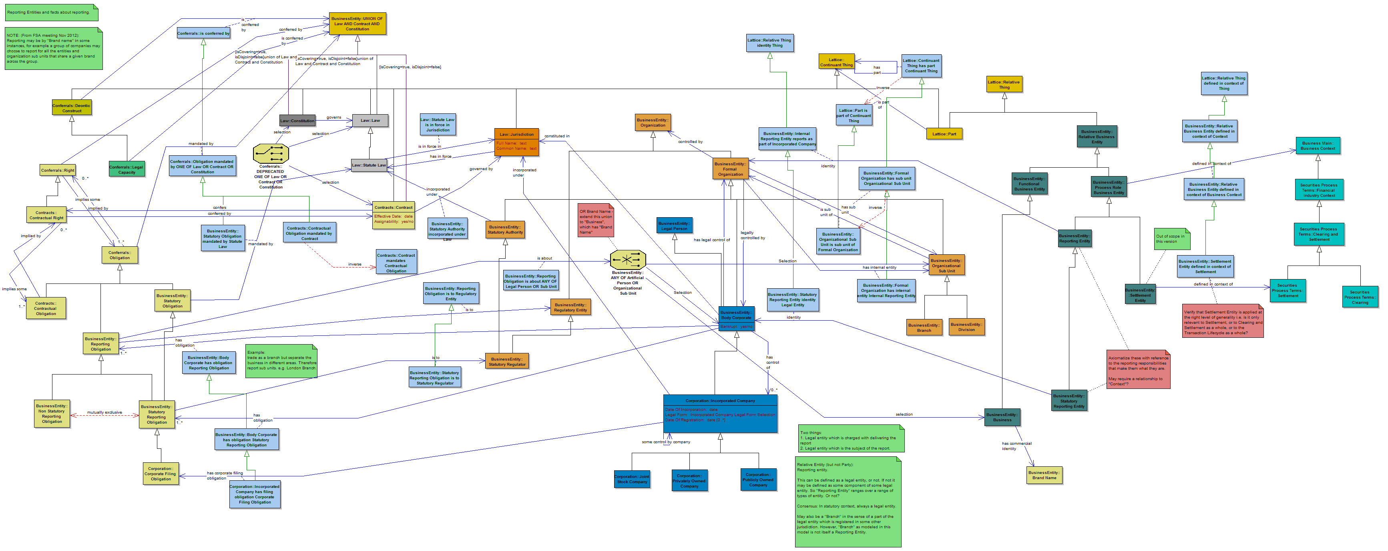

Figure 1: Reporting Entities - current draft model (from earlier reviews)

This diagram shows a part of the model we did not intend to include in the original release, and have not previously shown for wider review. The diagram shows:

- The kinds of reporting obligations which may exist (as obligations)
  - For instance reporting obligations, statutory versus non statutory
- The kinds of regulatory authority which these obligations are obligations to.
- The kinds of entity which have the obligations, i.e. those that are obligated to report or whatever
- The kinds of entity, in relation to which, something needs to be reported (i.e. some reporting obligation exists)
  - In this, we have a logical union (shown by the funny symbol) which refers to any one of:
    - Some Body Corporate
    - Some Organizational Sub Unit (e.g. branch or division)
    - NEW: Some "Business", this being defined as any kind of entity that is a business, and has a "Brand Name" as one of the facts about it.

The diagram also shows the context in which a number of process-specific entities (such as Settlement Entity) are defined. These, like "Business" are contextually defined types of entity - something which may be in one of several physical forms but which is defined in a specific context, in this case the context of some business process.

Relationships Conclusions
The different kinds of relationship identified above will be presented for review next week. Many of them were already in the model (some of them in a rather unfinished state, like the Reporting relationships shown). Others may need to be added. For the December draft we will stick to the simple relationships (share ownership based) but for the final version we will include all the relationships that are considered as being of relevance as identified above.

Action: Participants to provide details of what they consider to be of relevance in the various use cases that are important.

Renaming proposals
There are two proposals on the table for possible name / label changes.

- Legal Person / Liable Entity
- Legal Entity => Contractually Capable Entity

These are both shown in Figure 2.

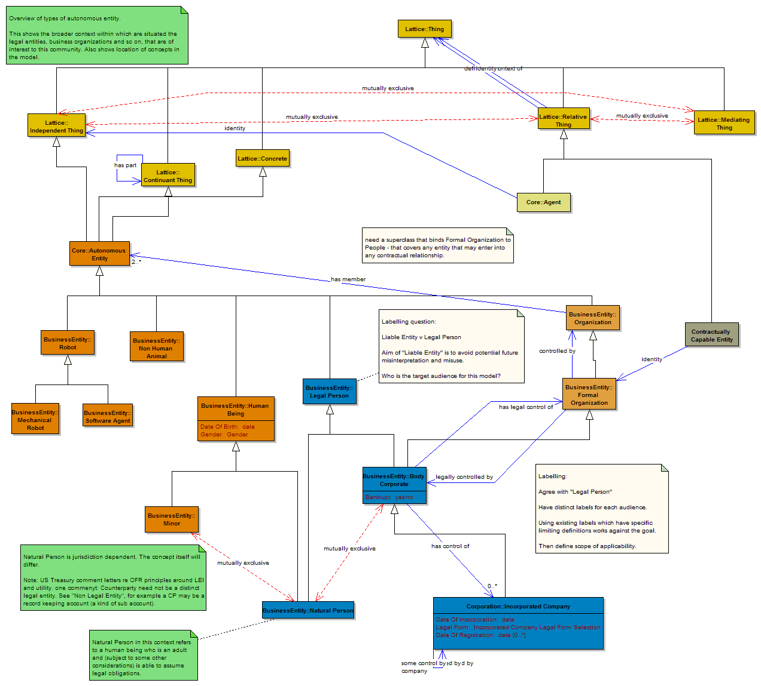
Figure 2: Basic entity types - with proposed new names.

Legal Person / Liable Entity
This class of "Thing" has been called Legal Person for a long time. In the mid-2021 draft it had the synonym "Legal Entity" but the latter was removed to a separate concept, to accommodate the ISO 17442 / LEI defined term, which has a different meaning (see below). The meaning of this term has remained unchanged for some time, and it refers to any entity which may incur liability.

Proposal:
- Change "Liable Entity" back to "Legal Person" in line with legal usage

Last time we had a proposal to change the term to the non-legal term "Liable Entity" in order to make the term more self-describing. This is because it is not clear to people without a legal background, what this term is intended to mean. When this was proposed, it was agreed that if Legal Person proved to be a legally-attested term then it would be OK to change it back to that. Subsequent conversations suggest that it is indeed.

See also feedback in the in-session Questions queue: this is the attested legal term.

Discussion: This also relates to what is the intended audience for this model. Mike B clarified that this is intended as a conceptual model and therefore has two audiences:

- Audience 1: Potential implementers of solutions (i.e. technical audience)
- Audience 2: Business domain experts who are expected to validate the model for completeness and correctness

Also there is the question of "grounding" i.e. where is the meaning of a term defined formally. For instance, academic work is always grounded in other published work or in direct observation. In law, meaning is grounded in law and contracts (or more accurately in court precedent, but for contracts we consider contractual terms themselves to be sufficient, otherwise terms have no meaning until they are challenged in court).

In this case, the terms for securities and derivatives are grounded in law or contracts, and we have taken the same approach with business entities - although there are clearly then other types of concept which are less legally grounded, as seen with the LEI scope definition. We decided to keep the concept of "Legal Person" even if not all applications will need it. This is because there are various kinds of legal person which may exist, and these have facts about them which relate to what kind of entity they are (e.g. share ownership) and so the existence of Legal Person in the taxonomy allows us to define these in "buckets" of common kinds of legal person. However most applications will focus on Formal Organization rather than Legal Person. For the thing we have that is Legal Person, we should use this as the label for it, as it is a well understood concept.

Alternative proposal:
- A long compound name with braces
  - "Legal Person (Liable Entity)" or
  - "Liable Entity (Legal Person)"

Conclusion: This approach is not preferred - good ontology practice would not support names that contain more than one label (see Tony Coates comment in the Questions file).

Contractually Capable Entity
Proposal: rename "Legal Entity" to "Contractually Capable Entity"
- Rationale:
  - self-describing
  - this is not a legal term so labeling less critical, self-describing should be fine

This means that NO term is labeled "Legal Entity"
- and two or more terms have this as a synonym

Consensus: All agree that, given that there are two or more meanings for Legal Entity in existence, we should not have it as a label for any of them.

Legal Entity Identifier
Here we moved to the "Common Identifiers" diagram to look at what is identified.

Considered the following:

The LEI scope item "Contractually Capable Entity" (FKA "Legal Entity") is a contextually defined concept - someone decides, in some context such as some jurisdiction, that a given entity is deemed capable of entering into contractual relationships and therefore deemed capable of needing an LEI. The question then is, what kind of entity actually has the LEI.

The alternatives were:

- Allocate the LEI to the contextually defined concept itself
- Make the LEI a fact about a context-independent, actual Thing, namely Formal Organization

Previous conversations have led to the conclusion we should do (2), that is, that once the need for an entity to have an LEI has been identified, the actual LEI should be allocated to a Formal Organization. It is then a fact about that thing regardless of any context in which it is used.

Consensus: Yes.

Proposals on taxonomic hierarchy and organization types
The above leads us to a question we have not really addressed yet. If the "LEI Scope" term refers only to Formal Organization, and the other side of the taxonomy deals with Legal Persons, then what we don't have is a single class of thing which may enter into any kind of contract or transaction. Specifically, natural persons can enter into contracts and hold liability (as Legal Persons) but are not included in the LEI scope of Formal Organization.

Similarly, we have defined "Formal Organization" as being some organization with some formal contractual relationship among the principals (covering trusts and partnerships as well as non natural legal persons), but many kinds of organization may open a bank account, without necessarily fulfilling this criterion.

Therefore we need a common concept for anything which may perform in any "Party" role, and we also need to refine the Organizations hierarchy a little more.

New "Potential Party" concept
Proposal: Have a common class of thing which is anything that may be a Party in some context.

In most data models, this would be called "Party" but we have used this label for a term which more closely matches the English language use of the word, namely something which is a party in some role, rather than simply something that may be.

Model action: Added a class to the model, as a parent of both Formal Organization and Legal Person.

Discussed what to call this. Proposals were:

- Party
- Potential Party
- Social Being

Agreed upon Potential Party. As well as being the self-defining term we came up with here, it has been seen with this label in some member firms' data models previously (since shortened to Party in that instance). Social Being would also work, and might fit in with the terms seen in John Searle's work, but is a little more alien to our universe.

Figure 3 shows this and some proposed new Organization terms (se next heading). We drafted this work in the more detailed diagram "Business Entities Common Classification and ID". A new diagram will be created in the Organizations section with all of the organization types that were discussed. The ones shown are what we added during the review session today.

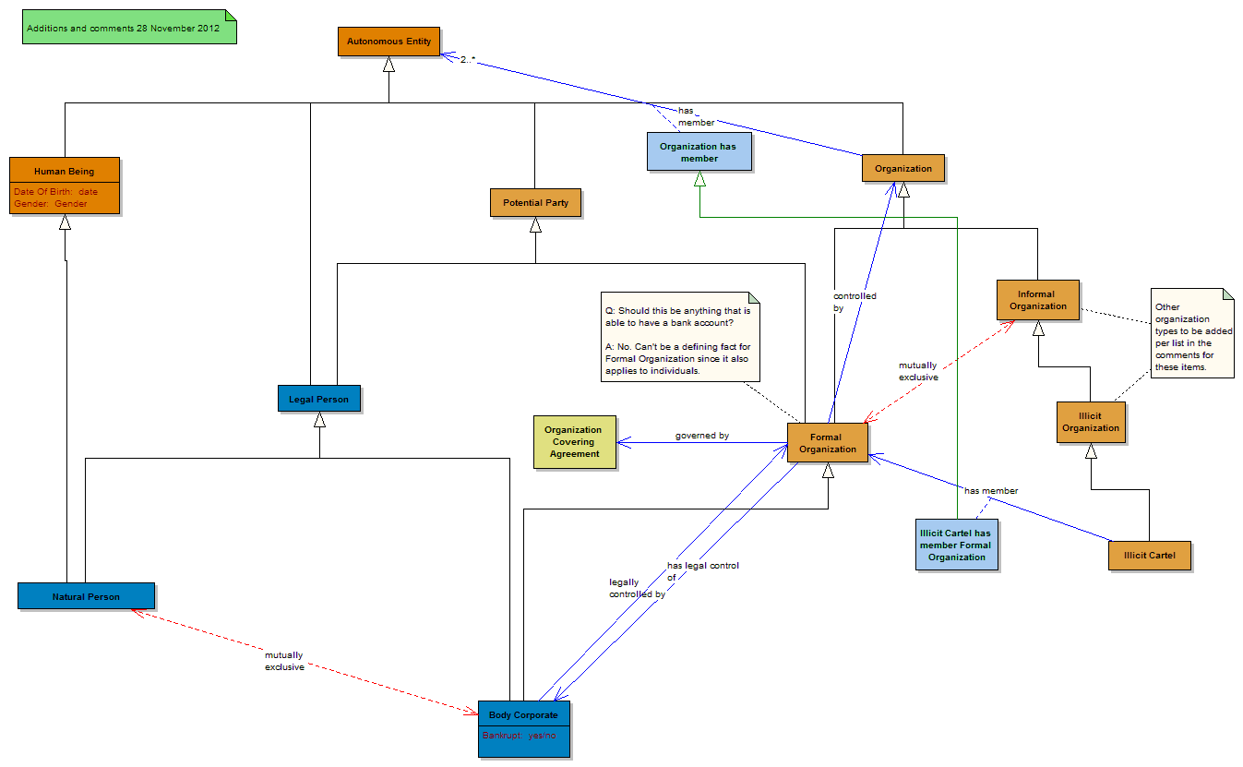

Figure 3: New Potential Party and Organization terms

Model Impact
The above new class "Potential Party" should now be the range (target) of the "identity" property for the relative term "Party".

This should also be the target of other contextually defined concepts, most notably "Business" (this currently points to "Autonomous Entity", which is far too general).

Organizations and cartels
In terms of "Organization", there is a mis-match between what may be a Formal Organization (defined as something with some formal agreement among its principals), and what may enter into some contractual relationship, being any organization that may have a bank account.

Proposal: need a kind of "Organization" that is more general than this.

Can't use the ability to open a bank account, as a defining fact about this, since individuals may also do so (and may open several including for example a sole trader having a separate account for the "Business").

Considered what is the precise scope and meaning of "Informal Organization" - does it include things which may open a bank account? Or can this be framed (as now) in terms of something not having some formal standing?

At RBS there are the following terms:

- [informal?] Organization
- Illicit Organization
  - Cartel
  - Crime Syndicate
- Legitimate Organization
  - Clubs etc.

Question on the term "Cartel": What about e.g. OPEC?

- OPEC etc. is a Trade Association the same as e.g. ABTA.

Discussion:
The term "Cartel" has two possible meanings, one of which covers illicit ones, so we will label the latter "Illicit Cartel" to clarify this. Then organizations which legitimately work together to some mutual goal, like OPEC, are basically kinds of "Trade Association", which we should also include (under Legitimate Organization).

A few of these were added to the diagram; the rest are to be added as above.

Note that on the "legit" side, any of these may open a bank account and therefore should come under our new common class of anything that may be a Party.

Cartel: Model Actions
- Added "Illicit Organization" as a sub type of Informal Organization
- Definition:
  - A kind of informal organization which is not legal. A covert organization.

- Added "Illicit Cartel" as a sub type of "Illicit Organization"
- Definition:
  - A collection of companies that come together to manipulate the market in some way. e.g. price fixing.

Question on this:
- Q: Does this make them formal organization?:
- A: NO; the members of the cartel are themselves formal organizations, but the cartel is not.

To model this, we added a relationship between "Illicit Cartel" and "Formal Organization". This relationship is the "has member" relationship, and specializes (is a sub property of) the relationship between Organization and Autonomous Entity, which defines the organization as being an autonomous thing with members.

Model Action: MB to add the remaining organization types as identified in the above list.

Common concepts
We moved on to the agenda item to identify the basic properties that need to be defined for business entities in general, and for specific types of entity (organizations, formal organizations, non natural legal persons (Body Corporate) and so on). These were in one diagram but it is quite cluttered so we created three diagrams for review with the main things we think apply to entities in general. These are:

- Names
- Addresses
- Identifiers along with other common terms e.g. sector classification codes

Organization Identification and LEI
In the diagram "Business Entities Common: Classification and ID"

The work in the preceding section was also carried out on this diagram - it is to be moved to a separate diagram (Figure 3).

Reviewed the LEI part of this model. This shows that the thing which is identified by the LEI is "Formal Organization"

Consensus: agreed.

Name concepts
Looked briefly at the name types on the diagram "Business Entities Common: Names"

- looks OK, did not have time for detailed exploration of this.

Noted that for most practical applications one would use plain text (datatype properties) for names. However they are included in this conceptual model as concepts, since a name is a concept. Also we saw earlier that there may be some minority cases where some names need to be reasoned over or referred to in data models, for example where one is interested in "Brand Name" as a unifying concept for a common group of entities for reporting or risk management purposes.

Address concepts
MB explained the basic thinking here. Did not have time to explore in detail. Looked at three aspects of this model:

- Registered addresses for legally incorporated entities
- Some of the ideas coming out of the Proof of Concept work on address roles (not shown)
- The basic address pattern which shows addresses as sets of textual fragments versus addresses as sets of physical location components

Registered Address
This is defined as being the address where papers may be served on an entity. In the original model, this led us to segregate it from other types of address and we identified this in terms of the fact that in most jurisdictions you cannot inckude a PO Box in a Registered Address. However it was noted then (and re-confirmed today) that in South Africa it is possible to have a Registered Address which is a PO Box. Therefore there is nothing intrinsic in the nature of an address which separates what may be a Registered Address from what may be any other kind of address (trading, headquarters etc.)

Address Relation
In the Proof of Concept work we have considered defining an "Address Relation", that is some address in some role. For example a trading address, a headquarters address and so on, are all addresses in a role, and the thing which may fulfill that role is itself simply an address, with regional legal variations as noted for Registered Address.

This fits well into our general pattern of modeling certain things as "Relative Things" (Peirce: "Secondness"), just like parties, actors and so on. The main reason one might want to define the relative entity in this way is to be able to add temporality, i.e. the date from and until which a given address performed the role defined e.g. when something became or ceased to be the primary / headquarters address, a trading address and so on, of a given entity.

For simplicity, this was removed from the diagrams we looked at today, and we simply looked at relationships from entity types to "Address". Once we have completely modeled the temporality and relative thing relationships, the end result should include the indication of the same simple relationships we looked at today.

Address Pattern
In common with many of the "Global" or foundational terms in the ontology, we have defined a general, high level pattern for "Address". At the most general level, this is more generic than postal address and is defined as "An index to a location". This encompasses network addresses, geospatial coordinates and postal addresses, and potentially other things such as account routing codes (if "Account" were defined as a kind of virtual place).

That is, an "Address" at its most general, is any information construct which by its nature will uniquely identify any kind of "Place", the latter being either physical (a "Location") or virtual.

Then we have introduced a new nuance to the postal address itself. This had previously been a very simplistic "holding pattern" while we sought a suitable external formal standard with semantics that we could refer to. We did not find such a standard. However, we did find two strong candidates for part of what we want: the VCard standard which defines textual elements which may be grouped to form the index to a location, and the UBL standard which has a very comprehensive set of types of location element that may be found in addresses.

The innovation is this: for some applications one is interested in a physical area or location (for example postcode areas are commonly used in risk management, particularly for mortgages); for other applications one only needs to see the textual elements that make up some "address" as a set of text on a document or envelope. We decided to combine the two (figure 4).

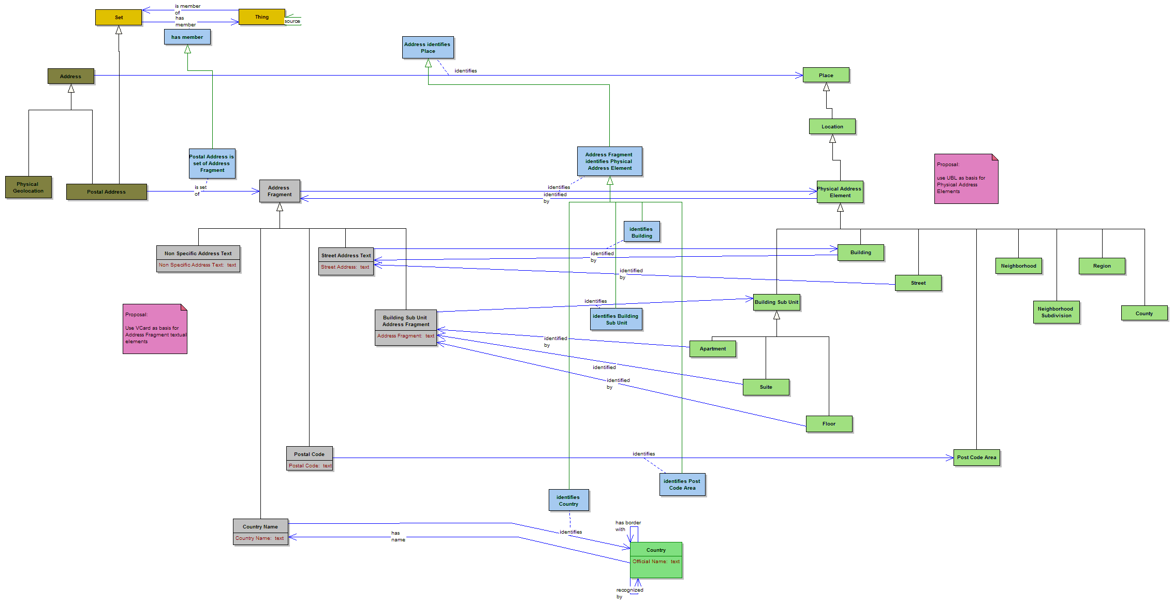
Figure 4: Postal Address concepts

What Figure 4 shows is that "Postal Address" as commonly understood is a "bag" or set of textual elements (ignoring ordering, which varies considerably between territories), in which each of the textual elements identifies some aspect of the physical location (or a post box, itself also a physical location but one remote from the recipient). Therefore a complete semantic treatment of these concepts would show that the Postal Address is a kind of "Set", and the members of that set are address fragments, and an address fragment is something that refers to one or a range of location constructs each of which is a part of the physical address of the addressee, with levels of granularity ranging from "Country" down to an individual building, floor, apartment or other sub-unit within some building. Or a post box.

Comment: a post box address differs from other forms of address in that it does not resolve to the location of the address, but instead resolves to a location where the addressee may collect mail (typically at a post office, at least in Southern Africa; in the UK it is not uncommon to find this resolving to a high street shop which provides this service privately).

Annex 1: Detailed Diagram Notes
The session notes above are detailed enough for any reading of this document. However, the notes below are provided for completeness of the record. See also the Questions Queue, which is included as Annex 2, and the Observations Log, to which all substantive questions and comments are added (including also some email comments during and immediately after the session).

Diagrams we recorded notes in today:

- Business Entities Common Classification and ID
- Autonomous Entities Overview
- Business Entities Common Addresses review

Notes in these Diagrams

Diagram: Autonomous Entities Overview

Labeling: Legal Person
Labeling question:

Liable Entity v Legal Person

Aim of "Liable Entity" is to avoid potential future misinterpretation and misuse.

Who is the target audience for this model?

New Entity Class - proposal
Need a superclass that binds Formal Organization to People - that covers any entity that may enter into any contractual relationship.

See separate diagram for implementation of this requirement.

Labeling
Labeling:

Agree with "Legal Person"

Have distinct labels for each audience.

Using existing labels which have specific limiting definitions works against the goal.

Then define scope of applicability.

Note that this was the person who proposed "Liable Entity" and who said at the time that this was provisional if the legal experts confirmed that Legal Person was unambiguously understood from a legal perspective.

Here followed a more detailed conversation about labeling and audience types.

Diagram: Business Entities Common Classification and ID
This is also the diagram where we added a couple of new Organization concepts, which are to be put onto a separate diagram in the "Organization" section.

Note on Formal Organization
Should be anything that is able to have a bank account?

This note updated later with

Can't be a defining fact for Formal Organization since it also applies to individuals.

New class: "Potential Party"
Definition:
Any entity which is able to perform any Party role.

Informal Organization - added narrative note:
Definition and Notes:
An organization which is not formally constituted in some way.

Further Notes:
Cartel: Is an Informal Organization
Is kind of Informal Organization

New class added: Illicit Organization
Originally called it Cartel. Then realized that Cartel was a kind of Illicit Organization but not the only kind. Update name to "Illicit Organization".

Definition and notes:
A kind of informal organization which is not legal. A covert organization.

Further Notes:
Does this term cover all types of illegal informal organization or just the ones do business or something?

See RBS model: In which:

Subtype to Ilicit

Illicit Cartel
Crime Syndicate

Legit
Clubs

OPEC etc. is a Trade Association the same as e.g. ABTA.

The above notes are the basis of new classes to be added after the session. See main notes for details.

New class added: Illicit Cartel
Definition and notes
A collection of companies that come together to manipulate the market in some way. e.g. price fixing.

Further Notes:
Does this make them formal organization: NO
The members of the cartel are themselves formal organizations, but the cartel is not.

Consensus: absolutely

(these discussion notes are to be tidied away out of the class now that they are recorded here in these notes for the record).

New relationship fact added: Illicit cartel has member
Range: Formal Organization

(no definition). This is the membership relationship for Cartel, reflecting the fact that members of a cartel are themselves formal organizations (but the cartel is not).

Diagram: Business Entities Common Addresses review

PO Box Address
PO Box address versus other types of address

The physical location has nothing to do with the user of that post box.

PO Box as Registered Address - South Africa
In the ZA context, PO Box is allowable.

Annex 2: In Session Questions and Comments
First Name | Last Name | Organization | Questions Asked by Attendee
Richie | Barter | Independent | Q: I had a couple of additional thoughts on SPV's and Trusts but I'll send them over by email before the end of the week. rgds Richie  A: --unanswered--  Q: From my experience the underpinning concept from a banks perspective is primarily defined around exposure upon default of an entity or counterparty and how best to aggregate and monitor exposures linked to that counterparty over time. Also key is to understand and monitor the changes in a given company structure over time. This is less from a reporting and more from a risk managment or trading perspective  A: I will interrupt Mike in a moment Richie. your line is released so you can jump in  Q: thanks, it was more related to the last point, happy to mute for now  A: got it!
Jacobus | Geluk | Consultant | Q: I would say the super type should be called "Actor". As Actors can play a Role.  A: --unanswered--  Q: So Legal Entity is basically the same as Body Corporate then  A: --unanswered--  Q: Sorry, microphone does not work here  A: --unanswered--  Q: Yes  A: --unanswered--
Robert | Schmidt | Wells Fargo | Q: We are going to sink if we try to regularize language.  A: --unanswered--  Q: I always wring my hands over how we label things - I think of it in linguistic terms as "semiotics" and try to keep it in that box. In software design we learn not to build meaning into our codes becasue invariably this leads to difficulty; this is a similar situation. We are building a comprehensive list of the kinds of relationships an entity instance can have. Two instances that do not share the same possibilities of relationship must be in distinct classes. If we fall back on naming these distinct classes as the US IRS does, for example 501(c)3, then we might be better off.  A: --unanswered--  Q: most actors I know do not have roles ...  A: --unanswered--  Q: If we ground this in law, does that mean that we would need a different model for each distinct legal system?  A: --unanswered--  Q: OPEC is a cartel right?  A: --unanswered--  Q: a bank account is a contract - right?  A: --unanswered--
Leona | O'Brien | University College Cork | Q: Having a bank account surely can't be a definnig factor of a formal organisation. There are several other categories that have bank account, ie a natural person  A: --unanswered--  Q: and therefore formal organisations  A: --unanswered--  Q: Hi Mike, Leona here from UCC, myself and the guys are listening and agree with your comments on the grounding of the terms in law  A: --unanswered--  Q: A cartel is a collection of companies that come together to manipulate the market in some way, ie price fixing. importantly they would be registered companies  A: --unanswered--  Q: This area is based on contract & company law so how can you discoount the legal definitions when there could be legal consqeuences arising from misinterpretation  A: --unanswered--
Anthony | Coates | UBS | Q: We do care about levels of ownership. Some vendor feeds actually list all shareholders and their shareholdings, where available.  A: --unanswered--  Q: I would rather see the ontology use standard ontology methods to indicate that two things (with different names) are the same, rather than concatenating the names into the one name fields.  A: --unanswered--
Cornelius | Crowley | US Treasury | Q: Re: ownership. Consideration of percentage of ownership reported as a regulatory obligation, as is done today, versus the potential to derive ownership at any point in time. What are the data modeling implications?  A: --unanswered--
Igor Ikonnikov | Ikonnikov | Manulife | Q: Suggestion: let's provide each entity with a definition and allow for multiple labels - each with a defined scope of appliability  A: --unanswered--
Dave | McComb | Semantic Arts, Inc. | Q: I sort of hate the term but we borrowed "SocialBeing" from Cyc  A: --unanswered--  Q: On the topic of term usage, seems to me if there is an unreconcilable ambiguity (as there is around Legal Entity) best to avoid the term, because if you use the term half of the audience will see the term and read into it their meaning,rather than the one you chose, and be confused rather than helped  A: --unanswered--

