FIBO-BE SME Review Notes 19 December 2012

Executive Summary
As usual, this document is in three levels of detail:

- This executive summary: describes what we talked about

- Session notes: captures resolutions and decisions made

- Verbatim notes: captures parts of the conversation verbatim for the record (Annex 1 & 2) - you do not need to read this.

Overview
This week we considered the types of relationship that go beyond the simple type of relationships we have considered previously.

The simple kind of relationships previously considered are those of "ownership with control", specifically arising from the ownership of voting shares in a company, by another company. By implication, there remain relationships in which the holder of that relationship is not a company, relationships in which the mechanism for control is something other than the holding of voting shares, and relationships which are not control relationships at all, but relationships of ownership (which of course may come with or without control).

We carried out some detailed analysis of the situations around various kinds of partnerships, both incorporated and non incorporated, as a means to flesh out what are the different kinds of relationship that may exist across formal organizations most generally (i.e. anything that may be allocated an LEI).

In the course of this, we found further clarity in the abstractions that exist in the model around partnerships. In particular, the model draft material around specific kinds of US and UK partnership, can now be better defined as abstractions of the necessary kinds of structure that may exist. This draws upon the changes identified last week (but not yet implemented) on the necessary and only ways in which legal persons may be brought into existence (equity and guarantees).

We also considered the existence of "Executive" parties (human beings with a formal role as executives within a corporate structure), and firmed up some of the existing draft material in this area. Also arising from this is a new and interesting form of relationship among entities, where individuals who have executive roles, may have these in different entities, and where this is considered to be the basis for "web of influence" relationships among those entities.

CONTENTS

Executive Summary 1
Overview 1
Session Notes 3
Summary 3
References 4
Discussion and Resolutions 4
Ownership and Control Relationship Types 4
US and UK partnership variants 9
Control Relationship Types 11
Partnerships 12
Executive v Legal Control 14
Executives Detail 15
Annex 1: Verbatim Notes 17
Diagrams with Discussion Notes 17
Verbatim Notes per Diagram 17
Diagram: Ownership Hierarchies Simple 17
Diagram: Business Entities Taxonomy 19
Diagram: Ownership Hierarchies Simple (revisited) 21
Diagram: Control Locator 23
Diagram: Partnerships 24
Diagram: Control Relationships working 26
Diagram: Organizational Hierarchies Working 26
Diagram: Partnerships (revisited) 28
Annex 2: Questions Log Contributions 31

Session Notes

Summary
This week we considered the broader set of relationships both of ownership and of control, building on our earlier discussions about ownership, and the existing "simple" relationship terms of corporate to corporate controlling ownership.

We considered what other forms of equity exist besides share ownership, and what relationships arise from these. This led into a detailed discussion of partnerships and the kinds of equity that may exist in specific types of partnership.

In the partnership discussion, we identified two orthogonal facets about partnerships: that of liability and that of equity or ownership structures. This will enable us to replace the existing classes that show country-specific types of incorporated partnerships, with a more generic model that reflects a sort of Venn diagram of the kinds of partnership that can logically exist. We also identified a new arrangement coming out of some US states, that broadens this set even further.

In this discussion we were able to identify what sorts of ownership and equity may exist in these different legal entity types, and what sorts of entity may participate in specific ownership and control relationships.

We also revisited the "Executive" control relationships that are in the earlier draft model material, and identified some shortfalls in that part of the model. This led on to a discussion of relationships between entities as they relate to the existence of executives in roles across multiple organizations, as well as combinations of executive control in one organization and formal ownership roles in others.

The actions to be taken going forward include:

- Model the facets by which types of partnerships may be defined
- Define the kinds of ownership and control which are not limited to share ownership i.e. elevate the equity-based relationships to cover the broader range of entities in which there is equity in one form or another - so for instance equity based controlling ownership need not be restricted to the more common case of limited company share ownership.

We should now be in a position to apply the set-theoretic logic of the FIBO modeling (Venn diagram) notation to the range of incorporated entity types and non incorporated entities, and to the range of ownership and control structures which exist. We expect to present an initial "straw man" representation of all these concepts, combinations thereof, and relationships based on these, at our next session.

We briefly discussed how some of these concepts can be put to work in applications, where the relationships between concepts we have captured here may lead to the discovery of more interesting relationships among entities.

We also learned that the material in the DTCC CICI documentation with relationships styled "Parent" that are based on 25% (voting or non voting) shareholding are part of ongoing discussions. We agreed that FIBO should not aim to represent these relationships but simply define the legally grounded concepts in a way that these ongoing discussions may make reference to.

In terms of scope, we agreed that this model should stay focused on the legally grounded or "de jure" terms, with only the most general representation of the existence of de facto relationships, since the latter may be what is asserted in physical data but can't be further formalized semantically. We agreed to removed "deemed" relationships from the model. We also don't need to model specific kinds of relationship based on percentages in data, other than the legally recognized (de jure) relationships of controlling shareholding and the relationships around that.

References
1. Searle, John R.: "Making the Social World - the Structure of Human Civilization", Oxford University Press, 2010. ISBN 978-0-19-539617-1

Discussion and Resolutions
During the session we followed several lines of enquiry. We started with the first diagram below, and moved between several of the diagrams that follow:

- Ownership Hierarchies Simple
  - Main discussion diagram
  - Notes on partnerships and equity
- Business Entities Taxonomy
  - Looked at US and UK partnership types and variants
- Control Locator (in FIBO-Foundations)
  - Discussed control types, scope
- Partnerships
  - Details on partnership properties, types, equity / parties
- Control Relationships working
  - Extract (created for this review session) from the "Organizational Hierarchies Working" diagram below.
  - Discussion on Executive v Legal Control
  - Correction of one term here
- Organizational Hierarchies Working
  - See extract (created for these notes) on Executive Control
  - Notes around Executive control

At one point we considered the role of executives in corporations, and made reference to a very complex draft diagram with these terms in it, that has not been tidied up for viewing - an extract of the relevant terms is given here, along with the detailed diagram we actually looked at. This is because the model contains a large number of relationships about control as well as ownership, not all of which have been previously presented for review or inclusion in the final material.

Ownership and Control Relationship Types
Discussion centered on the diagram showing basic ownership relationship types. We started with the review question shown on that diagram:

REVIEW QUESTION:
We have defined "Ownership" for something in which there is equity that may be owned (i.e. companies incorporated by the issuance of shares).

Are there other ways in which an organization, body corporate etc. be "Owned" other than through the holding of equity in the form of shares?

Are there other means by which equity in some entity may be held?

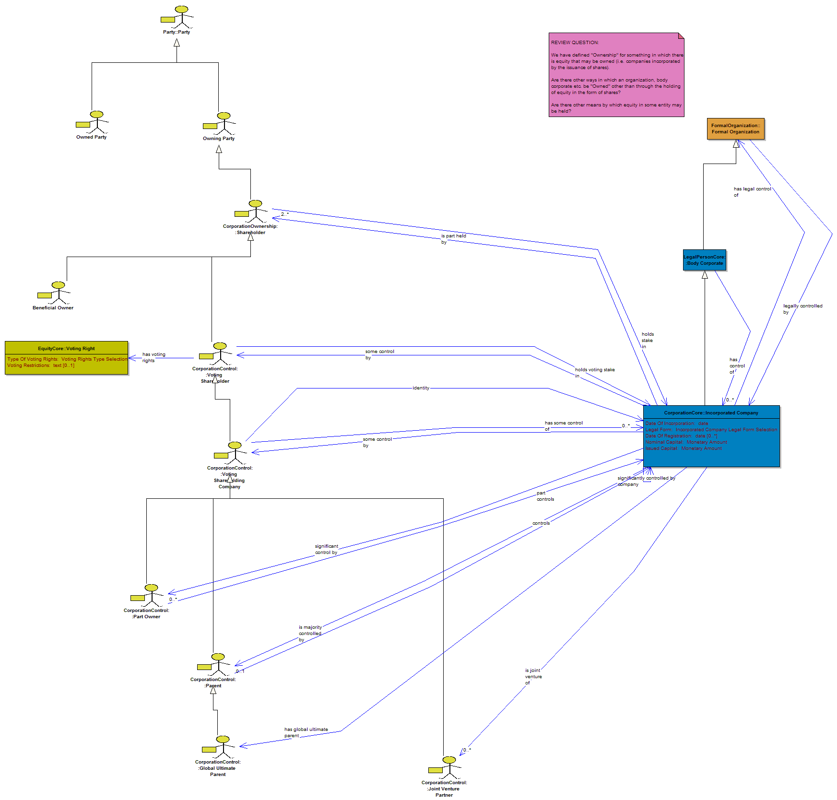

Figure 1: "Ownership Hierarchies Simple"

The current diagram only shows relationships which are based on the ownership of voting shares, and specifically such ownership by entities which are themselves corporations. The aim of this is to flush out what other ownership and control relationships exist among entities more generally, that are not explicitly covered in those shown above.

We focused on partnerships, in order to uncover examples that were not specific to limited companies and so identify the most generally applicable relationships.

Observations and Findings
- Partners in a partnership are "owners" of that partnership.
  - This is an ownership relationship.

- The stake that each partner has in the partnership is referred to as the "Equity stake" in the partnership.
  - In answer to the question on forms of equity, this confirms that there are forms of equity other than through shares in a company that has shares. The ownership stake which a partner has in a partnership is also an equity relationship
  - This is true of any partnership whether incorporated or not

- The percentage which each partner holds is determined in the Partnership Agreement.
  - Instead of share ownership percentages, there is still an equity percentage relationship, but it is mechanized through the Partnership Agreement not through shares.

Question: Then what of control as distinct from ownership? Is the ownership relationship identified above, also (and always?) a control ownership relationship (like holding voting shares)?

Answer: Yes.

- The percentages for "Control" etc. are determined by the percentages in the Partnership Agreement.

Question: how are these mechanized?

- The Partnership Agreement is where these are set out regardless of whether it is incorporated or not.

All of the above applies to all forms of partnerships, i.e. both those which are unincorporated and those which are incorporated. As we noted previously, incorporated entities (including incorporated partnerships) may be principle be incorporated either by the issuance of equity or by the issuance of guarantees. This gives rise to an obvious question:

Question: What about partnership incorporated by equity? Does all the equity in these partnerships, represent control ownership as described above? Or none of it? Or something in between?

Answer: there are two lots of equity in play: the general partners and the limited partners. The latter have their liability limited to their equity holdings. The general partners' liability is unlimited.

That is, for an incorporated partnership there are two kinds of partner: the General Partners, who own equity that comes with control (and unlimited liability), and a second kind of partner, the "Limited Partner", which holds some of a separate set of equity. As with the partners in a non incorporated partnership, general partners are jointly and severally liable.

Model requirements:
In all 3 cases, the Partnership Agreement covers it all.

Recall that "Partnership Agreement" is a specialization of "Organization Covering Agreement", a contract which must exist for (and is definitive of) any "Formal Organization".

Action: Extend the set of types of "Contract Terms Set" for Partnership Agreements, to cover these structures.

Summary:
There are relationships both of ownership (equity) and control in partnerships, and these differ across two kinds of partner, designated as:

- "General Partner" (for any kind of partnership), and
- "Limited Partner" (for incorporated partnerships)

Note: at present the model shows some specific examples of partner types for one of the US or UK specific types of partnership we identified in earlier reviews. We should now be able to frame these more generally in line with the above.

Incorporated Partnerships equity structures
Two types of equity are in play:

- Equity with control: this is the equity held by the General Partners
- Equity without control: held by the "Limited Partners"

Analogy:

Incorporated Partnership | Limited Company
General Partner | Voting shareholder
Limited Partner | Non voting shareholder

Limitations on Limited Partners' equity:
- Changes / increases in limited partner equity must be agreed by the General Partners
- Cannot be used as collateral outside of the partnership

That is, the equity held by Limited Partners cannot be traded.

Limitations on Partners' Liability
Incorporated Partnership | Liability
General Partner | Unlimited Liability
Limited Partner | Limited liability

Types of Partnership
The two types of partner described above translate to three types of partnership:

Partner Types |  | Partnership Type
General Partners | Limited Partners
Yes | No | Non incorporated partnership
Yes | Yes | Limited Partnership
No | Yes | Limited Liability Partnership

Note: This is independent of whether, for a legally incorporated partnership, this is incorporated by the issuance of equity or by the issuance of guarantees.

Legal Personhood
On the above:

Partnership Type | Is a Legal Person?
Non incorporated partnership | No
Limited Partnership | May or may not be
Limited Liability Partnership | Yes

Joint Ventures
Meaning: at its most general, the term "Joint Venture" is any venture carried out jointly between more than one entity. This may be mechanized in two or more separate ways:

- Through holding of shares
- i.e. the JV is a company in which shares are owned jointly by two or more other companies; no additional legal mechanisms are required to describe this
- Through the creation of a separate entity which is a Limited Liability Partnership

In the latter case, given that the Joint Venture partners are themselves legal persons with limited liability, it is not possible for these to participate in another entity in such a way that their liability is unlimited. Therefore the only way that a non human legal person (having limited liability) can participate in a partnership structure, is as a "Limited Partner".

That is, non human legal persons can't be General Partners in a Partnership, incorporated or otherwise.

Such non human legal persons may participate in a partnership which has Limited Partners, as Limited Partners. This is the case whether or not that entity also has General Partners. However, these non human legal persons can't be General Partners.

In the context of a Joint Venture, there are no General Partners. That is, Joint Ventures, if done as a partnership, have to be the Limited Liability Partnerships (there is no additional General Partner having by definition unlimited liability).

Partnerships Summary
There are specific types of partnership based on specific types of partner and the liability they may hold, and there are specific forms of partnership which may be used as vehicles in Joint Ventures (in addition to those JVs which are based on shareholding relationships).

Model actions:
The different properties outlined above should be modeled as separate facets in the universe of partnership types. This leads to a multi-faceted (multiple inheritance) taxonomy of types of partnership.

Whether a legally incorporated entity is incorporated via the issuance of shares or via the issuance of guarantees, is a separate facet which is orthogonal to each of the above. To be modeled as such.

Ownership and Control Relationships Summary

- The basic concepts of beneficial ownership and of de jure control, which have been described for limited companies, are now described also for partnerships.

- These can now be described as for all "Formal Organizations" with the appropriate specializations for limited companies and for partnerships of these various forms.

- These are all in scope.

Labeling
We did not reach consensus on what names to give the two relationships (ownership with control, ownership without control), that are defined above.

Mike suggested "Majority Stakeholder" and "Majority Controller". No other labels suggested. To be reviewed.

US and UK partnership variants
Overview: At present the model identifies the existence of "Legally Incorporated Partnership" and gives names of US and UK variants of these. With the information in the preceding section we should be able to deprecate these in favor of more general classification based on the properties which may exist for various types of partnership.

These are shown in a diagram of the overall taxonomy of types of entity in the model (figure 2).

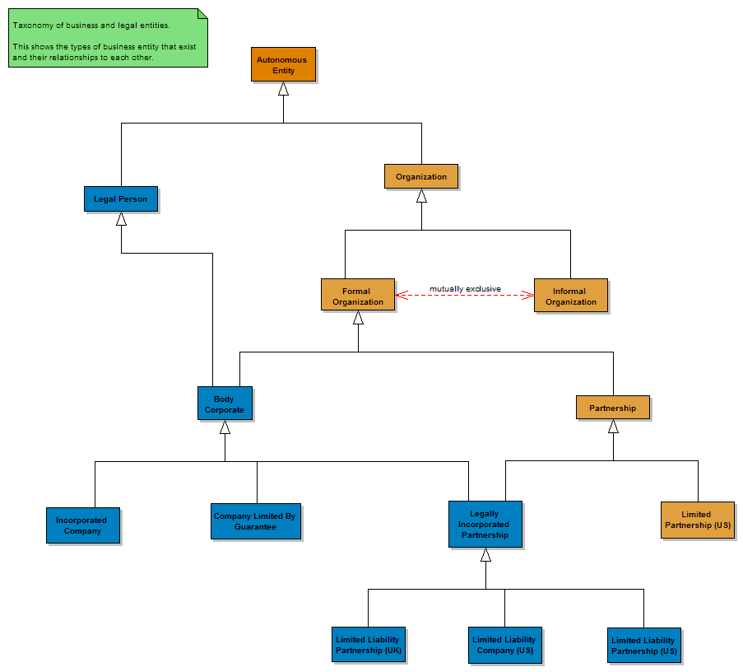
Figure 2: "Business Entities Taxonomy" diagram (extract)

Observations and Resolutions
- The UK entity "Limited Liability Partnership (UK)" is a legal person
  - Correct as shown
- The US entity shown as "Limited Partnership (US)" is NOT a legal entity
  - Correct as shown
- The US entity "Limited Liability Company (US)" is also a legal person
  - Correct as shown
- There is also a US entity called "Limited Liability Partnership". This is also a legal person
  - Added to model as shown above
- (later): there is, further, an entity in some US states called "Limited Liability Limited Partnership" (not a misprint - the word Limited appears twice).
  - To be added to the model
  - This is a partnership where the liability of the General Partners is also limited.
  - This is a Legal Person (i.e. incorporated)

However:

The style of naming given above is not appropriate - these kinds of jurisdiction-dependent entity names, with country initials in their names, are to be deprecated in favor of what are now the clearly defined forms which partnerships may logically take based on the factors identified in the preceding section.

The forms of the entities to be modeled are to be based on the properties identified in the preceding section, and not on tax treatments of entities.

Possible and Allowed "Owner" types
- In the US entity identified as "Limited Liability Partnership (US)", ownership is restricted to human beings
- In the US entity identified as "Limited Liability Company (US)", ownership is restricted to corporate entities

This identifies another, separate facet by which types of partnership entity may be defined: the range of kinds of entity which may participate in the "Ownership" relationships of that entity.

This clearly shows what kinds of entity may be the kind of "Party" which stands in an ownership relation, in respect to that kind of entity.

That is, the possible identity of the ownership party (and in operational ontologies, the domain of the "ownership" property between one entity type and another), is a defining fact about this kind of entity.

Ownership and Control Fundamentals
- Consensus / Finding: The relationship called "Parent" refers and only refers to de jure control of an entity by another entity.

- Consensus / Finding: The concept of "Ownership" refers strictly and always to the apportionment of equity in an entity
  - Equity is synonymous with ownership i.e. to talk about ownership in the pure sense, is to talk about equity, whatever form that equity might take

In addition to the above, we are also interested in other things which may bring risk in relation to an entity, including de facto control, other forms of influence etc.

Based on the Partnerships discussion, we should now be able to get to the fundamentals of what kinds of ownership relationship, and what kinds of control relationship, may exist for "Organization", for "Formal Organization", for "Body Corporate", and for specific kinds of body corporate or specific kinds of formal organization.

Control Relationship Types
To firm this up, we next worked on a diagram in the "Foundations" part of the model (figure 3), in a new section dedicated to what are called social constructs, that is formal "Things" which exist only by virtue of social consensus (see Searle's ontology - Reference 1).

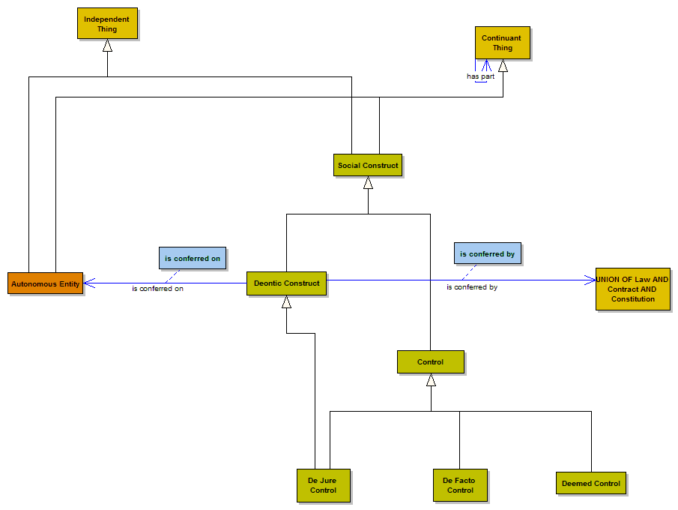

Figure 3: "Control" in FIBO-Foundations "Social Constructs" section

Control Constructs Background
The types of control which we talked about in a previous session as de facto control and de jure control, are now modeled specifically as social constructs called "Control". We haven't added any properties to these at present, and this might simply be a matter of defining and naming these kinds of control, in order to refer to them when distinguishing one kind of relationship from another.

We should also be able to define relationships from the kinds party (kinds of owner; kinds of controlling party) that are defined by possessing these kinds of control.

Technical note: in physical, operational ontologies, there is no data for "Control" as a social construct. However the forms of control in which we are interested should have some formal contract or comparable instrument, which is the mechanism by which such control is exercised. This will need to be described in any operational ontologies. An exception is "Deemed Control", which is now deprecated.

Executive Control
Another kind of controlling party previously identified in the model is that of the "Executive". This is some human person who has some formal managerial role in relation to a company, such as CEO, CFO and so on.

Correction to the existing model: The control exercised by executives is not a kind of "Legal Control". Remove the link that says this. See later discussion.

Control Relationships scope
- We should focus on the legal realities of things as they are known, rather than try to replicate relationships for specific e.g. 25% thresholds that may be of interest in data.

- We should not consider the 25% threshold as being set in stone.

- Meanwhile, the various groups responsible for these matters in the LEI world have still not landed on a final definition of ownership at this time.

- We may include some de facto control relationships subject to these being rigorously definable; these should be considered separately to the de jure relationships which are firmly in scope.

- Determinations based on valuations - these are considered as operational issues and therefore out of scope for this model

- In general, things which are strictly operational (i.e. determination of relationships based on calculation from data) are out of scope - as a conceptual model this should only reflect business concepts grounded in legal and contractual realities.

- The control concept labeled "deemed control" should be removed, along with the earlier terms of "Deemed Parent", "Deemed Subsidiary" etc.

Partnerships
There is a diagram which already has details of one or two jurisdiction-specific types of partnership. This includes the identification of specific kinds of "Party" in relation to one or two of these. See Figure 4.

Based on the work today, we should be able to re-frame these as more general concepts across the universe of possible partnership structures.

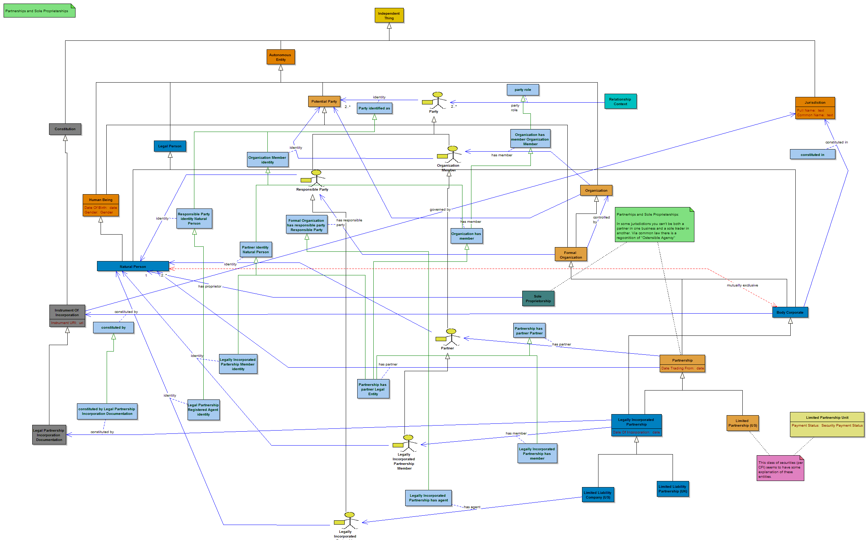

Figure 4: "Partnerships"

This diagram is quite complex, being the results of earlier SME reviews. Note the presence of specific types of party. This set of "Party" constructs needs to be extended with our new findings in the earlier section.

Partnership types
Add and distinguish between:

- General Partner
- Limited Partner

These are as described in the earlier section.

Affiliates
- Now that we have identified one kind of partnership where the partners are themselves companies in a Joint Venture, we need to model the relationship to (and meaning of) "Affiliate" in this context.

- Also there are affiliates in the sense already described through shareholding in incorporated companies, i.e. entities with a substantial but not de jure controlling interest
  - This is already in place and doesn't change.

- There are relationships between entities based on their having common partners or common directorships (so called webs of influence)
  - see note below on Executive types
  - these are referred to in this kind of relationship

Executive
- The parties defined as "Executive" in the context of incorporated companies, are directly equivalent to the concept of "Principal" in the partnership context.
  - Add as required for Partnership
  - Create more general level of party of which these are both a specialization

Executive v Legal Control
From the above discussion on relationships that are based on common holders of executive positions, we looked at extract from an old working diagram (see figure 5) that attempts to show the various kinds of control we have previously considered, and in particular that which is vested in "Executives" i.e. some kind of executive or managerial control. This is control vested in an individual.

For the control vested in such individuals, in the case of incorporated companies these are elected by voting shareholders, hence the de jure control defined in voting share ownership translates to the ability to appoint individual human beings who may exercise executive control.

We have come a long way in our thinking about these forms of control, so we needed to revisit this diagram and adjust as required.

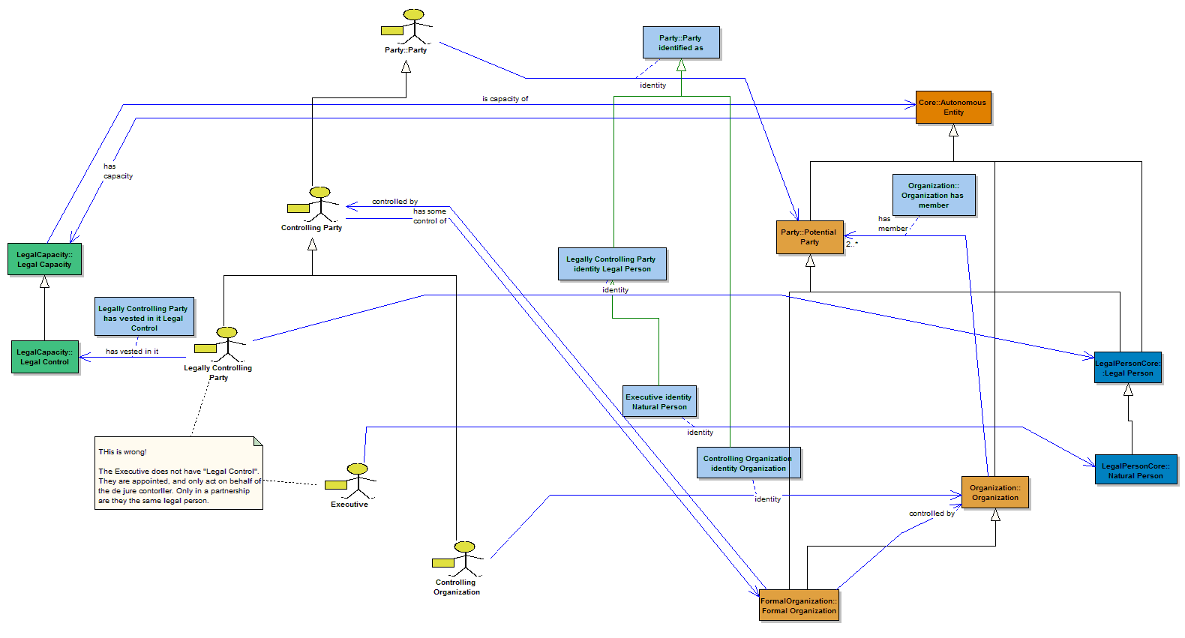

Figure 5: "Control Relationships Working" (extract)

Executive v Legal Control Observations
- Finding: The relationship which shows "Executive" as being a child of "Legally Controlling Party" is incorrect
  - Removed
  - The diagram shows this after removal
  - The corresponding specialization of the identity relationship should be removed in line with this

Rationale:
- The Executive does not have "Legal Control". They are appointed, and only act on behalf of the de jure controller.
- Only in a partnership are they the same legal person.

Original model rationale: What was originally meant by "Legally Controlling Party" was one that had control legally vested in it, rather than one which had legal control vested in it. A subtle distinction!

The existing concept of "Legal Control" has an definition which reads:

"Some capacity vested in some party to give them legal control of some entity, that is, a capacity to undertake legally binding commitments on the part of that entity. "

However, "Legal Control" may also be understood differently, to mean de jure control over a thing by another thing. This was the interpretation assumed today.

Actions:
- Clean up and align kinds of control versus kinds of capacity to exercise control on the part of others.
- We now have "Legal Control" under legal capacity, with the definition given above, and we have "Control" constructs separate from this.
  - These need to be aligned
- The meaning above needs to be associated with a better label, since on today's review this was interpreted (reasonably) as representing de jure control over an entity rather than (as given in the existing definition) the capacity to exercise this on behalf of the entity which does have de jure control
  - We need a label which identifies the capacity to act on another's behalf - this being what is vested in Executives.
  - See also earlier notes on agency and signatory capacities.

Executives Detail
The above concept and relationship is ancestral to a whole set of executive and non executive parties. These are shown in a separate diagram with a lot more detail. For ease of viewing, an extract of this is given as Figure 6.

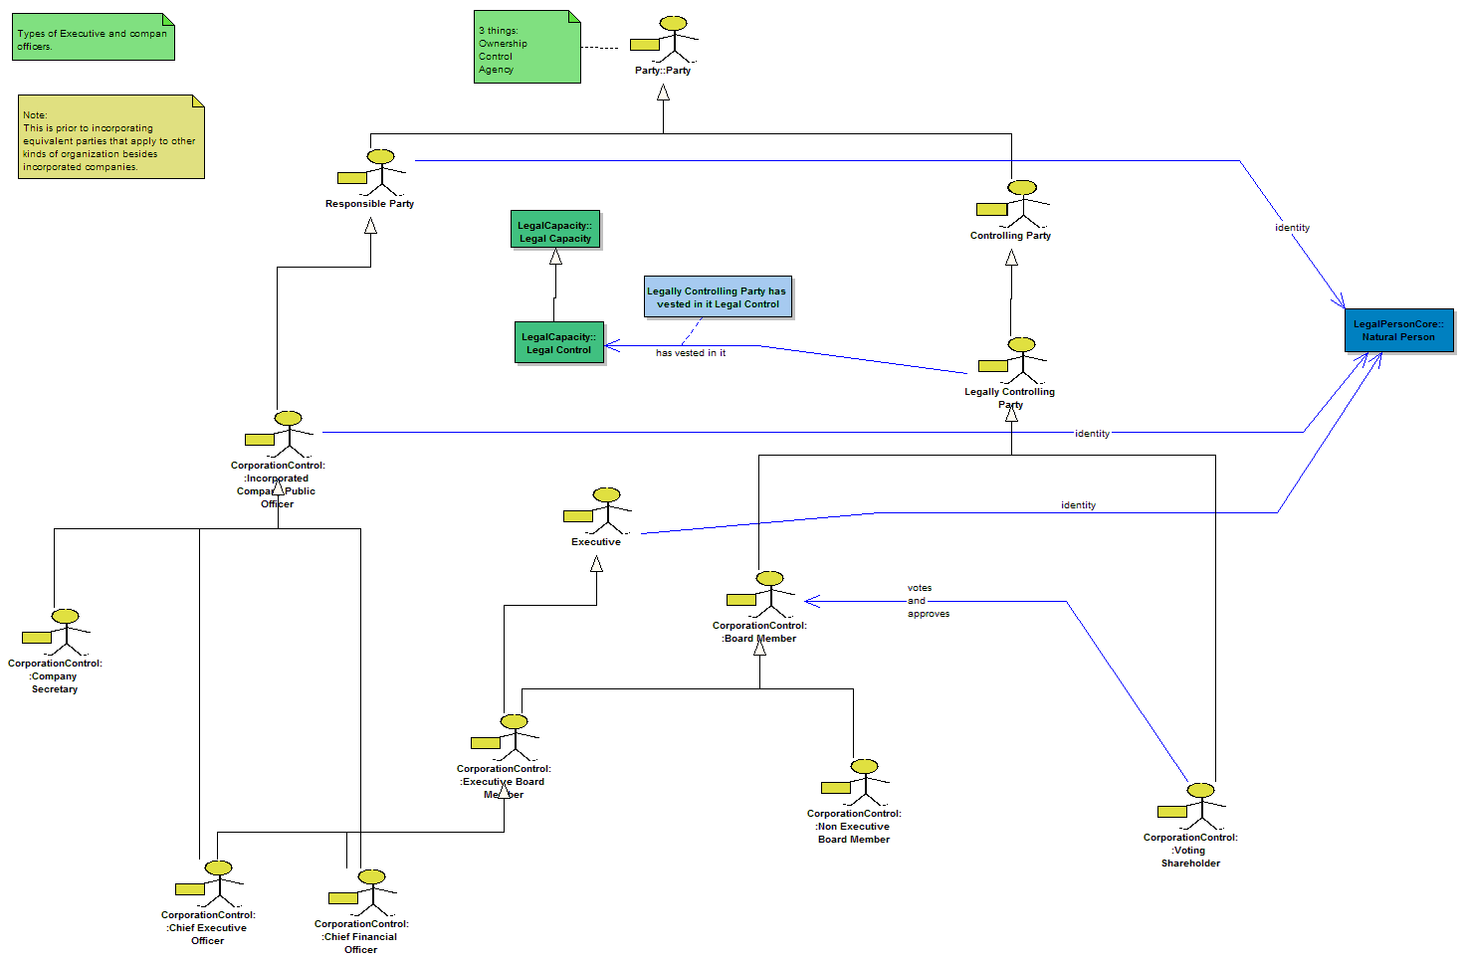
Figure 6: Extract from "Organizational Hierarchies" showing executives.

Observations and Actions

- Some of the party types identified in Partnerships also have Executive capacity in line with the terms given here
  - Specifically General Partners

- Define "Managerial Control" as a kind of control, and link to it here

With this in place, we were able to consider the relationships suggested earlier, which arise from common directorships / common general partners.

Common Directorships / General Partners
There are possible "webs of influence" based on common directors or general partners, as well as common ownership of stock (particularly voting stock i.e. control).

Kinds of commonality which may of interest include:

- Direct ownership
- Common principal(s)
- Common stockholdings in multiple companies.

Examples:

- CEO in one entity may hold a controlling stake in another company
- Someone owning a lot of shares in something but put in the name of relative etc.
- Relating these people to people who own stock in similar companies (same business sector)

Conclusions:

- These relationships may make up a "Web of influence"
- Model this by creating another kind of relationship, based on "Influence"
- Add "Influence" to the model
  - Note this is not a formal capacity
  - It may not be easy to frame this formally, other than to note its existence

Potential relationships between individuals and companies are already modeled in the model (i.e. executives, de jure control relationships are all defined), but the discovery of webs of influence will for the most part require analysis of the network of these in applications, looking at instance data. This is a potential application for semantic reasoning.

Annex 1: Verbatim Notes
This is the verbatim record of the conversations and contributions which are summarized in the preceding sections. See also the written questions in the GoToWebinar "Questions Log" in Annex 2.

As usual, the verbatim notes are shown indented like this;

Additional narrative and explanations are given like this.

Diagrams with Discussion Notes
- Ownership Hierarchies Simple
  - Main discussion diagram, notes on partnerships and equity
- Business Entities Taxonomy
  - Looked at Us and UK partnership variants; Igor's note
- Control Locator
  - Discussed control types, scope
- Partnerships
  - Details on partnership properties, types, equity / parties
- Control Relationships working
  - Correction and note on Executive v Legal Control
- Organizational Hierarchies Working
  - Notes around Executive control

We flicked between these a couple of times, as indicated below.

Verbatim Notes per Diagram

Diagram: Ownership Hierarchies Simple
What we covered:
  - Discussion on types of relationships
  - Notes on partnerships and equity

Pre-Review Question Note
We started with this question, raised by the Editor to start this conversation:

REVIEW QUESTION:

We have defined "Ownership" for something in which there is equity that may be owned (i.e. companies incorporated by the issuance of shares).

Are there other ways in which an organization, body corporate etc. be "Owned" other than through the holding of equity in the form of shares?

Are there other means by which equity in some entity may be held?

In response to this, we considered first the nature of partnerships (both incorporated and non incorporated), in terms of what ownership and control structures may apply to those.

The aim of this was to identify relationships which can be extracted to cover all formal organizations, all legal persons, all, all (and only) partnerships, all (and only) limited companies, all organizations and so on.

That is, we need to identify each of the kinds of relationship that may exist, at the appropriate level of abstraction for the relationship, and with subjects and predicates of each relationship referring to classes of entity at the appropriate level of abstraction in the business entities taxonomy.

Partnerships:

It is correct to refer to the relationship of the partners to the partners as "owners"

The stake that each partner has in the partnership is rightly referred to as the "Equity stake" in the partnership.

The percentage which each partner holds is determined in the Partnership Agreement.

Then the percentages for "Control" etc. are determined by the percentages in the Partnership Agreement. These are the same as in the holding of equity by shares.

The Partnership Agreement is where these are set out regardless of whether it is incorporated or not.

What about partnership incorporated by equity: there are two lots of equity in play: the general partners and the limited partiers. The latter has their liability limited to the equity holdings. The general partners' liability is unlimited. In all 3 cases, the PA covers it all., Regardless of how many general partners there are these are J&S liable.

Partnership Control
then: controlling stake lies with the General Partners.

The equity stake of the General Partners cannot be traded.

The additional equity in a limited partnership? There are restrictions on this, i.e. an increase in (or a change in?) the other equity has to be agreed by the General Partners. It cannot be used as collateral outside of the partnership. This cannot be changed, increased etc. without agreement by the partners.

Translating this to Model Relationships
So: what relationships are in play here?

- of control ownership
- of ownership more generally? Is there anything like non voting equity?

Limited partners are exactly like holders of non voting equity.

General Partners are analogous to voting shareholders.

Scope and Labeling of these Relationships
What relationships to track?

What to call them e.g. majority stakeholder, majority controller

Note in Questions Queue (Chris Barry)
Q: it was just around joint venture structures. I am on VOIP
Q: correct. the structures are correct being discussed' such as financing arms with manufacturers.
Q: partnerships are also done through joint ventures between two sepearate corporations.:
Q: structure of JV will fall under one of those 3 mechanisms.

Joint Ventures
See Chris Barry question at this point.

JV:
In UK - separate shareholders, no additional structure
2. limited partnership - where the JV participants must be limited in their liability.

You cannot have a limited liability entity participate in a partnership in such a way that their liability becomes unlimited.

A Ltd Co can't participate in an unltd. partnership; more correctly it can participate but not as a General Partner. It can still hold the other kind of equity.

Most JVs are limited liability partnerships. Two cos can get together and form a limited liability partnership

JV can't have General Partners. Most JV partnerships are limited liability and there is no General Partner that has unlimited liability. These are "Limited Liability Partnership"

Limited Liability Partnerships Note
This note was started earlier, and revisited after the above discussion on Joint Ventures.

This is not the case where it is Limited Liability Partnerships.

Limited liability is orthogonal to whether it's guarantee or equity.

GP: Unlimited liability
Ltd Partnership: mix of GP and Unltd Partners are described (may or may not be legal person)
Ltd. Liability partnerships: No GPs, every partner has limited liability. (is legal person)

In both the above, the mechanism by which a partnership that is a legal person may be equity or guarantee.

Ltd Liability partnership IS a legal person.

Diagram: Business Entities Taxonomy
What we covered:
  - US and UK partnership variants;
  - Scope and re-work requirements for partnerships.

Limited Liability Partnership (UK)
Note attached to this class:

In the UK this is a corporate body which has independent legal personhood

This assertion agrees with the current model, where this class has a parent of "Legally Incorporated Partnership", itself a child of "Body Corporate" and having the archetype of "Legal Person".

Limited Liability Company (US)
Note attached to this class:

US:

Ltd Liability Company - is a Legal Person
Ltd Liability Partnership - is a Legal Person

Ltd Liability Partnership: restricted to ownership by people
LLC: ownership restricted to corporate bodies (which ones)

This note suggests that, as well as the existing class called "Limited Liability Company (US)" - which is rightly defined as a legal person, we also need a separate and similar class called "Limited Liability Partnership (US)" which is also a legal person. The notes given above may go into the formal definitions or editorial notes for that new class and for the existing class, as appropriate.

Specifically, the facts about these which distinguish one from the other, is the based on the range of kinds of entity which may have some ownership in the entity.

Added: Limited Liability Partnership (US)
Added a new class of entity called "Limited Liability Partnership (US)" in line with the above notes.

No definition or notes included in the class at this point.

Action: add the notes from the accompanying diagram notes.

Legal Personhood / Legal Entities in Partnerships
This note was added near to another class that exists in the model, labeled "Limited Partnership (US)". This class is shown as being a kind of "Formal Organization" but NOT a kind of Legal Person (it has the archetype for "Business Entity", not that of "Legal Person"). Needed to establish whether today's reviewers agree with this. Also this is just after we added the new class above, so we needed to clarify the position of both the new term and the existing term.

Note text:
Both partnership and Limited Partnerships are NOT separate Legal Entities, but a Limited Liability partnership Is a separate Legal Entity.

The distinction can be formalized in terms of the joint and several liability.

In the US, there are tax relationships which reflect these legal realities - the tax treatment is different among different kinds of partnerships, e.g. pass through of tax liabilities to the partners.

In the US, the taxes for these versus LLP, LLC - the latter are taxed as distinct entity.

Cannot assume that the tax detail always follows the liability nature of things, though it seems to. There are also state-specific or jurisdiction specific variations. In the US the Fed defines what are the acceptable structures from a tax POV.

This note confirms what the model already shows, i.e. that the US term called Limited Partnership is not a legal person, and that the US term just added, called "Limited Liability Partnership", is a kind of legal person. This assumes that the speaker was using the term "Legal Entity" in its common legal usage, as a synonym for "Legal Person", and not the alternative usage in the LEI world, which is heteronymous to this, as we have already established.

Partnerships Labeling - From Questions Queue (Igor Ikonnikov)
Q: If we follow the paradigm of adding a country ID to a term (e.g.: "Limited Partnership US", "Limited Partnership UK", "Limited Partnership RU", etc.) we may end up with an unmanageabale number of terms. I think we could recur to a couple of options: (1) create a general term like "Legal Entity Type" and treat concepts such as "Limited Partnership US", "Limited Partnership UK", "Limited Partnership RU" as instances of this type; or (2) create general concepts (types) like "Limited Partnership", "Limited Liability Company", etc. with a "Domicile" (or "Scope") attribute.

Discussion: All agree with this.

Previously. Mike had put in the terms we have just been looking at (and added the new one today along the same lines), showing jurisdiction-specific names of kinds of partnerships in just two jurisdictions (one federal, so actually about 53 jurisdictions!).

Now that we have identified more detail around ownership, equity, liability and the role of the Partnership Agreement in formalizing these in both incorporated and non incorporated partnership types, it should be possible to use these new kinds of fact (when they are all modeled i.e. extensions to the "Terms and conditions" elements around the Partnership Agreement), then it should be possible to formally model the range of partnership forms that may logically exist.

The specific US and UK variants of these would then be sub-types of those, or better, removed from the model as being local jurisdictional variations and not globally standard concepts.

Action: As above. See also later note where yet another variant was added to this list of kinds of partnership.

Diagram: Ownership Hierarchies Simple (revisited)
Following the above exploration of forms of partnership (both legally incorporated and not), we went back to the original diagram of kinds of ownership hierarchies and picked up the discussion there:

Ownership, Incorporation and Equity
Discussion was whether the two kinds of way in which a partnership may be legally incorporated (issuance of equity; issuance of guarantees), has any bearing on the liability structure.

This is not the case where it is Limited Liability Partnerships.

Limited liability is orthogonal to whether it's guarantee or equity.

GP: Unlimited liability
Ltd Partnership: mix of GP and Unltd Partners are described (may or may not be legal person)
Ltd. Liability partnerships: No GPs, every partner has limited liability. (is legal person)

In both the above, the mechanism by which a partnership that is a legal person may be equity or guarantee.

Ltd Liability partnership IS a legal person.

Note that "GP" above refers to "General Partner". This concept may exist whether the partnership is legally incorporated or not, and is a "Party" that has some relationship to the Partnership. This concept may also not exist, as in the third example given. This gives us more insight into the range of possible partnership types based on the range of possible facts about a partnership, as noted in the discussion in the previous diagram. That is, we should be able to create a multi-faceted hierarchy or taxonomy, based on faceted classification principles and using multiple inheritance, to model these correctly (representing the "Venn diagram" idea noted above).

Action: Create new taxonomy of potentially existing kinds of partnership, based on the separate facets about the liability structure, the equity structure and/or the existence of guarantees in place of equity as a means of attaining legal personhood.

Owner Concept
Note adjacent to the various "Owner" types in this diagram e.g. Part Owner

Owner concept:

See the de jure v de facto conversation.

"Owner" strictly the apportionment of equity.

Parent: De jure Control only. Has to own more than 50% of the voting equity.

We are not just interested in Legal Parent but also things that bring risk i.e. the de facto control.

This note clarifies the "Parent" relationship as defining only de jure control, and goes on to identify further scope that is distinct from this.

The question being asked here was whether there is anything that can be called "Ownership", which is anything other than synonymous with the concept of "Equity".

Conclusion: there is not. Ownership (in an entity) is synonymous with equity. There are many kinds of equity in an entity and these are not restricted to equity instruments as such (i.e. shares or share-like fund units). However, every scenario in which some person or entity has an ownership relationship to some other entity, is on in which the ownership is synonymous with that entity having some form of "Equity". And every form of equity ownership is formally set out in some way, as we have seen from the wide range of partnership scenarios.

This is what we wanted to confirm.

Having dealt with ownership, we now moved on to consider control.

Diagram: Control Locator
What we covered:
  - Control types, scope

Came to this diagram in the course of discussing the kinds of control there are - here are the new terms we introduced as a result of the discussion on the previous (5 Dec) session on de facto and de jure control. These are now modeled as actual kinds of "Thing" (concept) that are the control themselves (a kind of social construct, based on John Searle's ontology of social constructs (ref 1)). These have not yet been connected to the parties that exercise the kinds of control that are defined here, but they will be.

This was in response to the correction in the "Executive" and the kind of control which it exercises (wrongly defined before as Legal Control). Note also that Legal control is modeled previously as a kind of "Legal Capacity" so there is some duplication between this and the new "social construct" types of control introduced in this diagram.

Comment on scope
Comment:

The LEI 25% figure: the private sector participatory group continue to discuss these concepts. Have not finalized that "Parent" equates to 25% threshold as suggested. The semantic distinctions we are discussing continue to be an active area of discussion. Will not be finalized for some time.

So in our model we should stick to the legal realities.

For instance, accounting convention of 50% v the CFTC Part 45 rulemaking for CICI, which is where we saw the 25% figure. Various rulemakings center around the 25% figure, along with levels of 10% and 5% for various conditions. Also discussion looks at accounting rules, and the rulemaking the jurisdiction under which the LE may reside, e.g. if a given jurisdiction calls 2% "Parent" then that would be the definition of Parent in that jurisdiction.

Also on this, the following was noted in the Questions Queue (Cornelius Crowley):

Q: The Private Sector Participatory Group and Implementation Group continue to discuss the concept of ownership. They have not landed on a final definition at this time.

That is, we should not take the 25% figure as being something that has been finalized or something that is set in stone as a specific kind of relationship that we should try to model.

Ownership versus Control.

These discussions would define a new flavor of de facto control but would not over-ride the definitions of de jure control in any given jurisdiction.

Scope for this conceptual ontology: Keep it legal. Define all the concepts that have a legal grounding.

Following from the above comment, our aim and scope has to be to define the concepts that exist, as grounded in legal realities - not to feel that we should capture various relationships such as "25% Control" which may be described in the ongoing (and still incomplete) work on the LEI relationship requirements.

Determinations based on Valuation
Also to consider: valuation based determinations? Operational issues are separate to what's modeled in this legally grounded model.

The conclusion from this point was that operational application considerations, such as determining relationships based on calculations from available data, is not something we should be concerned about in drafting this model.

Deemed Control
We could simply identify these at the most general level but not try to model.

Deemed control allows one to implement a percentage in the implementation.

As a counterpoint to the above thinking: we had previously introduced to the model the concept of "deemed control" precisely to cater for new kinds of relationship which are not grounded in some defined reality such as "50% + 1 share voting share ownership", to allow us to talk about relationships which someone has come up with, in which control is deemed to exist. We added classes called "Deemed Parent" and "Deemed Subsidiary" in an earlier draft, and gave these a "simple fact" property defining the threshold at which something might be deemed to be a parent.

Consensus: is that these terms are not needed

Action: Remove from scope.

Diagram: Partnerships
What we covered:
  - Partnership properties
  - Partnership types, equity / parties

Here we looked at an example of the kinds of detail that have been previously and provisionally modeled against one of the partnership types. We should now have enough information to model these more generically and as they apply to the types of party that are common to various types of partnership and the types that are specific to, and perhaps partly definitive of, specific types of partnership.

These are the parties that will have roles relating to ownership, control and the like.

Partner (party types)
Note adjacent to Partner, Legally Incorporated Partnership Member:

General Partner v Limited Partner.

Details: at present the model has a number of "party" constructs*, around Partnerships. These include "Partner" as a party to the most general class of "Partnership" (i.e. the kind of partnership of which all the variants modeled, are specializations). We also added some specific party concepts for "Legally Incorporated Partnership" in general, and for the specialization of this which is identified as "Limited Liability Company (US)". Clearly there should be similar, and additional, party types for different kinds of legally incorporated partnership.

(* a party is some entity in some formal or legal role).

Affiliates etc.
While modeling these concepts:

Also model the concepts of affiliate or Associate Company:

1. company A holds less than majority shareholding (voting) in company B - substantial not non de jure controlling interest.

2. Two companies that are associated through common partners Or common directorships. Regardless of if it's a Director or General Partner:

We have companies which have common principals (Director OR General Partner).

Executive is synonymous with Principal.

Discussion: it seems that in addition to party roles of the type normally fulfilled by human persons, there are other entities that have some "part" in some kinds of partnership, which are themselves companies of some sort. That is, the range of kinds of entity which can play the role of some of the kinds of "Party" defined for certain kinds of partnership, may be broader than human beings. For other kinds of parts in other kinds of partnership, these may be restricted to being people only. Hence affiliate or associate company may be defined in this kind of partnership structure, at least where the partnership is the formal structure of some joint venture.

However this note clearly goes beyond the current discussion on partnership party types, and embraces other kinds of relationships among entities, which we need to also consider.

Therefore, we moved along to a diagram which covers more about control relationships in general, in order to pick up this point.

Diagram: Control Relationships working
What we covered:
  - Executive v Legal Control (Correction and note)

There is a large diagram called "Control Relationships", containing most of our earlier workings on control relationships. This includes a lot of relationships which were considered to be too detailed for our current scope, i.e. various different kinds of control. From this the Editor created a diagram for today's review, called "Control Relationships Working", which covers only the basic relationships we want to think about now. In the light of the preceding comments, which of these kinds of relationship do we want to consider for inclusion, and which of the previously modeled relationships are right or wrong?

Executive
This is a class of "Party", shown as being a sub-class of "Legally Controlling Party", that parent class being some "Controlling Party" which has vested in it a legal capacity called "Legal Control".

Noted as follows:

This is wrong!

The Executive does not have "Legal Control". They are appointed, and only act on behalf of the de jure controller. Only in a partnership are they the same legal person.

Refers to the superclass relationship to Legally Controlling Party", which was then removed.

When this was previously modeled, we meant that the party has some form of control vested in it by some legal means. This is different to saying that the entity has some legal control over the entity. In any case, the kind of control that is vested in the Executive of a company is not vested by law, but by (company) by-law or by some other means by which the company (not the law) vests control in some individual for some executive purpose (e.g. CEO, CTO, CIO and the like).

Therefore this was wrong.

In a partnership, some party which has legal control over the entity, and some party which has executive capacity, may well be the same individual. In that case, what the model would show would be two kinds of Party since these are still distinct meanings, but with no reason that the two Parties might not in fact be the same individual.

Moving on...
The whole area of "Executives" is in fact modeled in a separate and very cluttered diagram, which has not previously been presented for review. We moved on to look at that diagram. For ease of viewing, a separate diagram has been created for these notes which shows only the relevant parts.

Diagram: Organizational Hierarchies Working
What we covered:
  - Notes around Executive control

Came to this after talking about the kinds of party in Partnerships, and noting that some of these were synonymous to the terms we already have for "Executive", so this was a good time to look at those terms in the existing "Managerial Control" parts of the model.

Also talked about some scope and application considerations while we were on this diagram (and perhaps switching between diagrams).

Executive
Managerial Control - define that as another kind of Control, then link it to this kind of Party.

Discussion: This replaces the mis-framed idea of this kind of entity having some "Legal Control". Need to add Managerial Control to the overall "Social Constructs" model of kinds of Control. Need to then model what are the kinds of instrument through which this specific kind of control is conferred on some individual.

New Relationship Types - Common Directorships/Partners
Then we can look at the relationships based on common directors (or General Partners etc.).

Examples e.g. someone owning a lot of shares in something but put in the name of relative etc.

Can then relate those people to people who own stock in similar companies (same business sector):

Web of influence:

Direct ownership
Common principal
Common stockholdings in multiple companies.

These are 3 things of interest. Used FOAF to track this with DTC information to create some interesting maps on these.

For instance CEO in one entity may hold a controlling stake in another company - this effectively relates them. So there are relationships across the kinds of different relationships that we have now teased out the relationships between.

Stealth ratings are based on these non easily visible inter-relationships between entities. At some point you can only assert these using a simple ontology like FOAF. Can now talk about more kinds of relationships via FIBO.

Discussion: this relates to a kind of relationship (or a set of kinds of relationship) which is distinct from all the ones we have now formally defined. Here, what is of interest is some possible "web" of relationships of influence, that may obtain between corporate or other entities, and that may exist as a result of indirect relationships between entity - person and person - entity. For example, where the same person holds formal roles in relation to more than one company or entity.

There may be a lot of these. The simplest implementation is to model the concept of another construct called Influence. This is similar to our social constructs of ownership and control (but presumably does not feature in Searle's ontology of social constructs, since influence is not a socially constructed concept). Needs thought.

Application Considerations
Applications: You don't know what you don't know. Sooner or later, need to look at the data and look for patterns, additional facts etc. in the application.

Discussion: The question arose at this point about whether this kind of thing should be included in scope, particularly as it is hard to frame formally.

The point here is looking at possible applications of the FIBO Business Conceptual Ontology. Like any conceptual model, one can't (and arguably shouldn't) try to anticipate every one of the physical applications that might be written that might need to make reference to that conceptual model. Mike gave an example from recent discussions with the UK's Financial Services Authority, where they came up with a hitherto unsuspected use case for formally reasoning over kinds of name (for reporting with reference to brand names). A purely application-driven approach to what to include in this conceptual model, would have led us not to include kinds of name as things to reason over.

This is a good reason to ensure that what we include in this business conceptual model, while it should be as simple and as constrained as possible, can legitimately include things for which we don't at present have a defined use case.

The above discussion on webs of influence is a very good example of this requirement. We may not know what are the physical applications that might make reference to these concepts, but they are of interest to our constituents and should be included. We may also not have knowledge of the kinds of properties that formally define these concepts just yet (and so may not be able to populate semantic technology applications with instance data for these), but the concepts exist and should be catalogued as such.

Diagram: Partnerships (revisited)
With the above notes in mind, went back to the "Partnerships" diagram. This is the diagram that shows kinds of incorporated and non incorporated partnership, and which has some of the kinds of "Party" that have been uncovered so far, for specific kinds of incorporated partnership.

Following on from our earlier conversation, someone remembered yet another kind of partnership structure, with yet another very similar but different name:

Limited Liability Limited Partnership
One more to add to the list:

The Limited Liability Limited Partnership.

This exists in the US only. Might be a logical intersection of the two facets we talked about. To be researched. May be a state-dependent thing.

What we do know of in US:

LLP
Ltd. Liability Ltd Partnership

Discussion:
This is not a typo, the word "Limited" appears twice in the name of this additional entity. That is, it is an entity with limited liability, and it is a "limited" partnership (whatever that means - see final note below).

Previously in the model we had (taxonomic relations shown as indentations here):

- Partnership
  - Limited Partnership (US)
  - Legally Incorporated Partnership
    - Limited Liability Company (US)
    - Limited Liability Partnership (UK)
    - Limited Liability Partnership (US) added today

This new thing is something different again. It is something called "Limited Liability Limited Partnership" in certain US states (see below), but does not mean the same thing as what we called Limited Liability Partnership in the UK. It is also not the same as the "Limited Liability Partnership (US)" we added earlier today.

As a sanity check we asked what kinds of partnership-like entity people on the call know of in the US. The response covered today's new "Limited Liability Partnership" (LLP), as added today, and this new one, "Limited Liability Limited Partnership".

As noted previously (see verbatim diagram note on "Limited Liability Company (US)" today, in the diagram "Business Entities Taxonomy"), a limited liability company is a kind of legal person by definition, a limited liability partnership is a legal person for the same reasons (liability of the entity is limited), and a limited liability partnership may only have people as partners (not other corporates) while a Limited Liability Company or LLC may have partners which are corporate bodies of some sort (and not human beings).

As noted above, it should be possible to see all of these variants in a kind of Venn diagram of the kinds of entity that can exist, the existence of limited liability, the existence of partnerships, the kinds of entities that may be partners and the kinds of partners that various kinds of entity may or may not be. One new fact, added by this new concept, is the variation in the extent of liability that different parties in the partnership may have (see final note below).

The model notation we use defines everything as a set theoretic construct, so these "classes" will correspond to Venn diagram components. The multiple parentage of these classes of thing will correspond to logical intersections in the Venn diagram.

Action: In implementing the earlier note (whereby we model a multi-faceted hierarchy of the kinds of thing that there can be and deprecate the country-specific terms), we should ensure that this new kind of entity can be described as one possible class or set of entities, and we should add this in the notes for that entity (as we also will for all the other "... (US)" and "... (UK)" items we have in the model at present). Those will then be deprecated from the model.

Where did this new thing come from?
It's a new thing.

AK, AZ, CO, Delaware, TX, KY, GA, MD and FL

This is where even the general partners liability is limited. So this is a new legal arrangement.

CNN is one of these.

These are some of the states in which there is legislation under which this new kind of entity can exist.

The defining fact about this new kind of entity is that the liability even of the General Partners (and not only of the other kinds of partner) is limited. Hence the double use of the word Limited in the name - once because the entity has limited liability and once because the General Partners' liability in the entity is itself limited.

Annex 2: Questions Log Contributions
Contributions to the discussion, raised in the GoToWebinar "Questions" queue.

As far as possible these have been replicated at the relevant point in the detailed notes above.

First Name | Last Name | Organization | Questions Asked by Attendee
William | Freeman | KMSolutions | Q: covenants can be quite varied. .
Cornelius | Crowley | US Treasury | Q: I left out that this is for the LEI  Q: The Private Sector Participatory Group and Implementation Group continue to discuss the concept of ownership. They have not landed on a final definition at this time.
Chris | Barry | CIT | Q: it was just around joint venture structures. I am on VOIP  Q: correct. the structures are correct being discussed' such as financing arms with manufacturers.  Q: partnerships are also done through joint ventures between two sepearate corporations.:  Q: structure of JV will fall under one of those 3 mechanisms.
Igor | Ikonnikov | Manulife | Q: If we follow the paradigm of adding a country ID to a term (e.g.: "Limited Partnership US", "Limited Partnership UK", "Limited Partnership RU", etc.) we may end up with an unmanageabale number of terms. I think we could recur to a couple of options: (1) create a general term like "Legal Entity Type" and treat concepts such as "Limited Partnership US", "Limited Partnership UK", "Limited Partnership RU" as instances of this type; or (2) create general concepts (types) like "Limited Partnership", "Limited Liability Company", etc. with a "Domicile" (or "Scope") attribute. (Sorry, I don't have a voice line.) Thank you. Igor

